Anchor End User Guide

Last Revised: Wednesday, January 18, 2017

Table of Contents

Getting Started
Your File Sync Tool allows you to share files and folders across your devices, and helps you collaborate and share content with others. Using the system, you can
- Collaborate with members of your organization, as well as with people outside of your organization;
- Manage file revisions and versioning;
- Audit and track your files;
- Share files and folders through email with the Outlook add-in; and
- Back up and restore important files.
This User Guide will help you set up and use the system, and will provide you with the information you need to incorporate the system’s toolset into your daily work activities.

How to Log in to the Web Portal
When a user account is first created for you, you will receive a Welcome email from your administrator, providing you with important information to help you get started using the system. For example, your email might include a link to the web portal, a username (or an email address), and a password.
- Navigate to the URL listed in your email (for example, https://www.syncedtool.com).
- Enter your username (or email) and password.
- Click the Log In button.
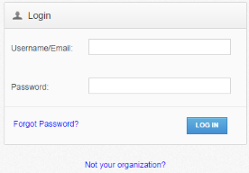
You now have access to the system.

How to Manage Account Settings
In the web portal, you can update your account settings, including your name, email address, and password. You can also set up advanced settings, such as Two-Step Authentication, quota alerts, and WebDAV access.
To manage account settings:
- Click the Logged In As button in the web portal.
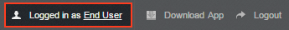
The Account Settings page displays.
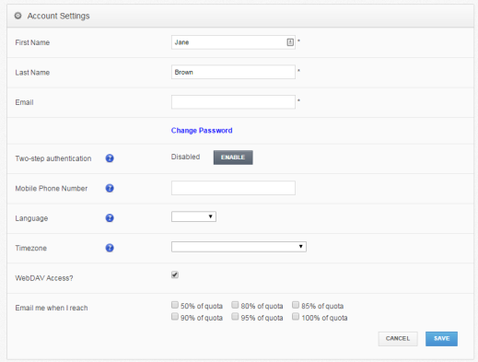
- In the Account Settings page, you can update account information, including:
  - Use the First Name field to update your first name.
  - Use the Last Name field to update your last name.
  - Use the Email field to update your email address.
  - Click the Change Password link to change your password.
  - Use the Mobile Phone Number field to change your mobile phone number.
  - In the Language drop-down menu, select your preferred site language,which controls the language settings displayed in the web portal and mobile apps, as well as number formatting. Leave this field blank to use the default language set for the system, which you will see displayed when you hover over the blue Question icon.
  - In the Timezone drop-down menu, select your preferred timezone, which affects dates and times displayed across the system. You can also leave this field blank to use the system default, which you will see displayed when you hover over the blue Question icon.
- Optionally, in the Two-Step Authentication section, click the Enable button to enable Two-Step Authentication. Two-Step Authentication adds an extra layer of security to your account. Each time you log in to the web portal, or register a desktop client, the Outlook add-in, or a mobile device, you will be prompted to enter an authentication code. This code will be delivered to you through a mobile app, a text message, or an email, depending on your settings. For more information, please reference the How to Configure Two Step Authentication section of this guide.
- Optionally, click the WebDAV Access checkbox to enable WebDAV access.
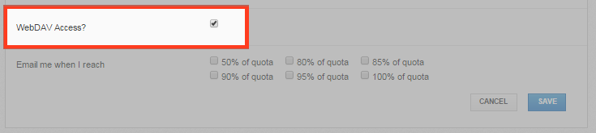
- You can also use the Email Me When I Reach checkbox fields to configure alerts when you reach a certain percentage of quota.
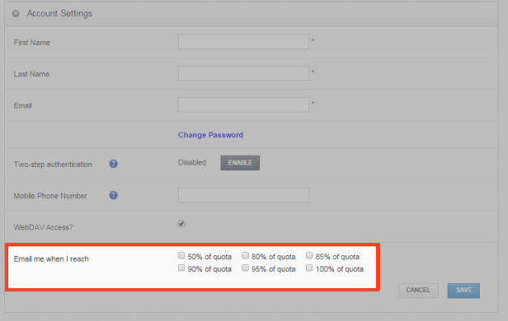
- Click the Save button when you are finished making changes to your account.

How to Configure Two-Step Authentication
In the web portal, you can optionally configure Two-Step Authentication for your account. In some instances, your administrator might require that you set up Two-Step Authentication.
Two-Step Authentication adds a second verification step when you log into the web portal, or register the desktop client, the Outlook add-in, or a mobile device. With Two-Step Authentication, you will be sent an authentication code through an Authenticator Mobile App, text message, or email, depending on your selected configuration. You must then enter this authentication code—along with your username and password—before you can access the web portal, or register the desktop client, the Outlook add-in, or a mobile device.
Two-Step Authentication can be configured in one of two ways.
- You can optionally configure your own Two-Step Authentication settings in your Account Settings page.
- Administrators can also require the use of Two-Step Authentication for your organization. If your administrator has turned on this policy, you will be prompted to configure your own Two-Step Authentication settings as soon as you log in to the web portal.

Configuring Two-Step Authentication
To configure Two-Step Authentication:
- Click the Logged In As button in the web portal.
The Account Settings page displays.
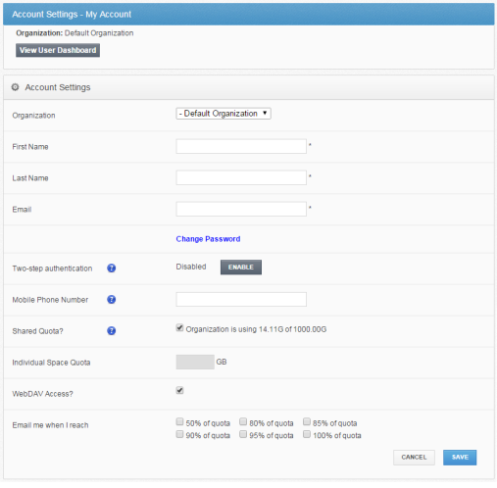
- In the Two-Step Authentication section, click the Enable button.

Note: Your administrator might require that you use Two-Step Authentication. If you are required to set up Two-Step Authentication, you will be prompted to configure an authentication mode when you log in to your account in the web portal.

You will be redirected to the Enable Two-Step Authentication page.
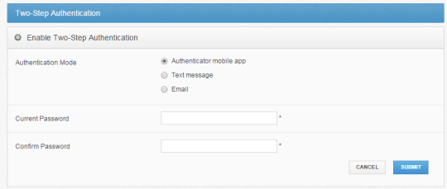
- In the Authentication Mode field, select the delivery method through which you want to receive your authentication code. You can choose from Authenticator Mobile App, Text Message, and Email.

Note: If you select Authenticator Mobile App as your delivery method, you must install an authenticator app of your choice, such as Google Authenticator, Amazon AWS Virtual MFA, or any of the many other TOTP-compatible apps available for download.

- In the Current Password field, enter your password.
- In the Confirm Password field, confirm your password.
- If you selected Text message as your delivery method, you will also be prompted to enter your mobile phone number.
- Click the Submit button when you are finished. You will be redirected to the Confirm Two-Step Authentication page, which will vary based on your selected delivery method.
  - If you selected Authenticator mobile app as your delivery method:
    - Save the Backup key that is listed in the confirmation page. You will need this key if you need to recover access to your account.
    - On your mobile phone, install a mobile authenticator app, such as Google Authenticator, Amazon AWS Virtual MFA, or any of the many other TOTP-compatible apps available.
    - In the mobile authenticator app, create an account, and enter the secret key to confirm your identity, which you will find listed in the Confirm Two-Step Authentication page. A few mobile authenticator apps, such as Google Authenticator, will allow you to scan the barcode to confirm your identity.
    - In the web portal, enter the authentication code provided by your authenticator app in the Authentication Code field.
    - Click the Submit button when you are finished.
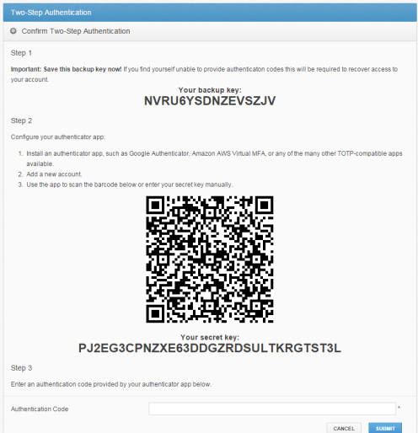
  - If you selected Text message as the delivery method:
    - Save the Backup key that is listed in the confirmation page. You will need this key if you need to recover access to your account.
    - You will receive a text message with an authentication code. Enter that code in the Authentication Code field.
    - Click the Submit button when you are finished.
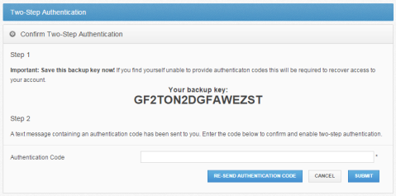
  - If you selected Email as the delivery method:
    - Save the Backup key that is listed in the confirmation page. You will need this key if you need to recover access to your account.
    - You will receive an email with an authentication code. Enter that code in the Authentication Code field.
    - Click the Submit button when you are finished.
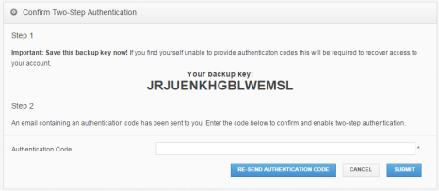

Accessing the Web Portal
After your Two-Step Authentication settings are configured, you will be prompted for a second step authentication code each time you log in.

Note: Authentication codes are only valid for a limited amount of time. Make sure you enter your validation code promptly.

If you are ever unable to provide the correct authentication code, you can use the Backup key to recover your account.
- In the Login page, click the Unable to access authentication codes link.
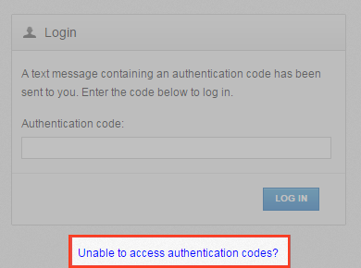
The Account Recovery page displays.
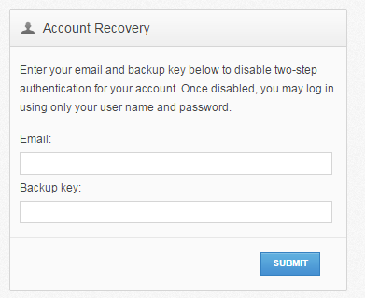
- In the Account Recovery page, enter your email address as well as the Backup key that was saved when you first configured your verification settings.
- Click the Submit button when you are finished. When Two-Step Authentication has been disabled, you will be able to log in using just your username and password.

Registering the Desktop Client
When registering the desktop client for the first time, you will be asked to enter an authentication code.
- If Two-Step Authentication has been enabled for your organization or for your user account, you will be prompted to enter an authentication code at the time of registration.
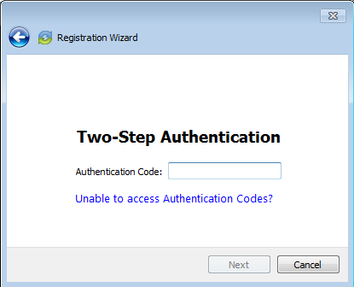
- After you receive your authentication code, enter the authentication code and press the OK button. You can then complete the registration process.

Registering and Accessing Mobile Apps
When accessing your mobile app for the first time, you will be prompted to enter an authentication code. You will also be asked to configure a passcode (also called a PIN if you are using an Android device) when you access your mobile app at subsequent sessions.
- If Two-Step Authentication has been enabled for your organization or for your user account, you will be prompted to enter an authentication code at the time of initial registration. Enter the authentication code and press the OK button.
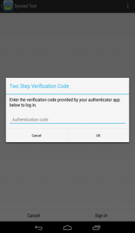
Image of the Android App Two Step Authentication Prompt
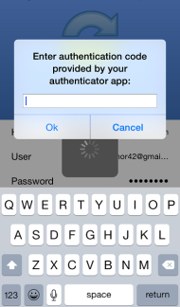
Image of the iOS App Two Step Authentication Prompt
- f Two-Step Authentication has been enabled for your entire organization, you will also be asked to configure a passcode (for your iOS device) or a PIN (for your Android device). At subsequent sessions, you will be prompted to enter this PIN or passcode when you access your mobile app.

Note: If Two-Step Authentication has been turned on only for your user account (either by you or by your administrator) you will not be required to configure a passcode or PIN.

  - On an Android device, you will be directed to the Settings page. Select Require PIN.
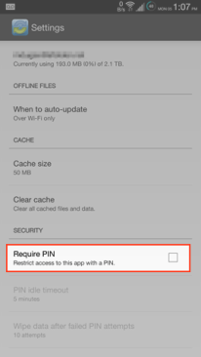
You will be prompted to enter a PIN.
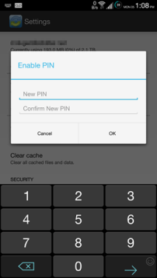
  - Alternatively, if you are using an iOS device, you will be directed to the Settings page. Select Use Passcode.
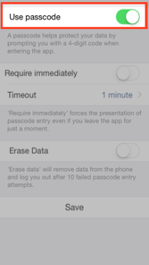
You will be prompted to enter a Passcode.
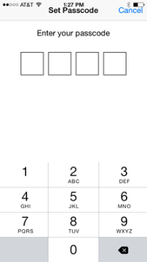
  - When accessing the mobile app in the future, you will be prompted to first enter this PIN or passcode.

Registering and Accessing the Outlook Add-In
When accessing the Outlook add-in for the first time, you will be prompted to enter an authentication code. You will also be prompted for an authentication code when opening a new Outlook session, or when changing your add-in credentials.
- If Two-Step Authentication has been enabled for your organization or for your user account, you will be prompted to enter an authentication code when you open Microsoft Outlook.
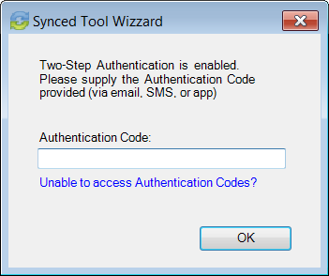
- After you receive your authentication code, enter the authentication code and press the OK button. You will be prompted for this authentication code at the time of add-in registration, when opening a new Outlook session, or when changing your add-in credentials.

The Web Portal
After you have an account, you can begin to create and upload content into the web portal. The web portal provides user-friendly features—including drag and drop functionality, multi-select options, and the ability to view dozens of file types directly in your web browser.
In the web portal, you can access your personal dashboard, search for files and folders, and manage your personal and shared content. For example, you can:
- Click the Files tab to access your files and folders.
- Click the Shares tab to access Team Shares, items shared by you, and items shared with you.
- Click the Guests tab to collaborate and share with people outside of your organization.
- Click the Backups tab to create and manage your backups.
- Click the File Report tab to view or export a list of your files.
- Click the Activity Log tab to review your activity within the system.
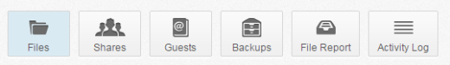

How to Upload Files in the Web Portal
When files and folders are uploaded to the web portal, all of these items will propagate down to any of your connected devices, such as your mobile device or your local machine. You can access your uploaded content from any computer that has a supported web browser and an Internet connection.
To upload files in the web portal:
- In the web portal, click the Files tab. The Browse Files page displays.
- Navigate to the appropriate location, and then drag and drop files and folders onto the page, or into a personal folder or Team Share. Uploaded folders will retain their original structure.
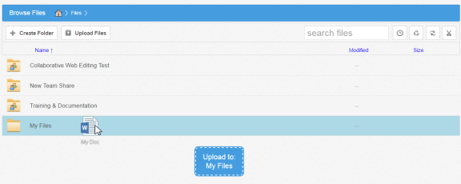
An Upload Files pop-up window displays, showing you the status up the upload process.
  - Alternatively, while inside the appropriate folder, click the Upload Files button. The Upload Files page displays.
  - In the Upload Files page, you can drag and drop files onto the page and click the Upload button. The files will upload. Or, click the Add Files button to manually search for files on your local machine. The files will upload.
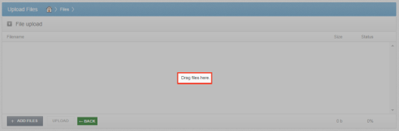

How to Manage Files and Folders in the Web Portal
You can manage all of your files and folders in the Browse Files page of the web portal. In this page, you can utilize advanced drag and drop functionality, create folders, upload files, and manage revisions. You can also preview dozens of file types directly in your web browser, and edit files simultaneously with coauthors using the fully integrated Collaborative Web Editor.

Finding Content
- In the web portal, click the Files tab. The Browse Files page displays.
- In the Browse Files page, you will see a list of all of your files, folders, and Team Shares.
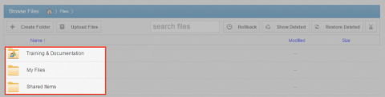
- To quickly organize your content, drag and drop files and folders within the Browse Files page. You cannot drag and drop a personal file or folder into a Team Share. You can, however, drag and drop personal files and folders, or drag and drop files and folders while inside a Team Share.
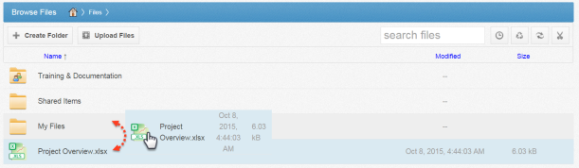
- You can also select multiple items at one time by holding down the Shift key on your keyboard. You can then perform mass actions, including download, lock, move, deleted, and more.

Previewing Content
- To preview a file in your web browser, right-click the file and select View. Or, simply click the file to view its contents.
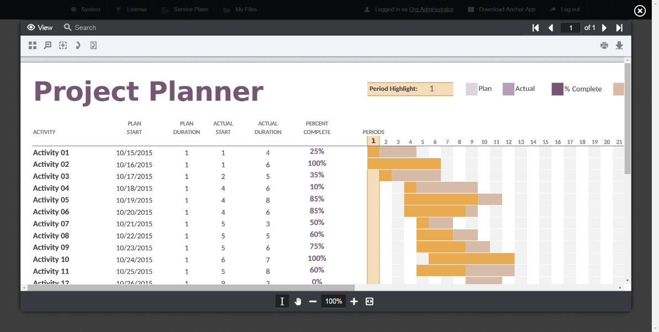
The selected file will open in the Web Preview tool, allowing you to utilize advanced search tools, select and copy text, print, download, and more.
- Click the Close button when you are finished previewing the file.

Editing Content
- Right-click a file and select Edit.
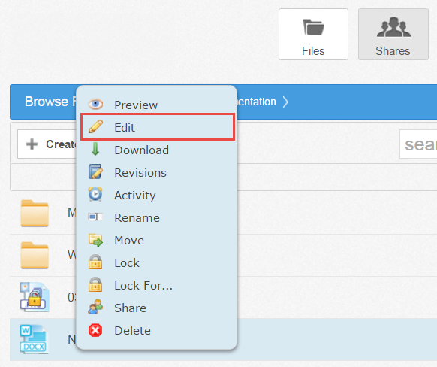
The file opens in the fully integrated, real-time Collaborative Web Editor.
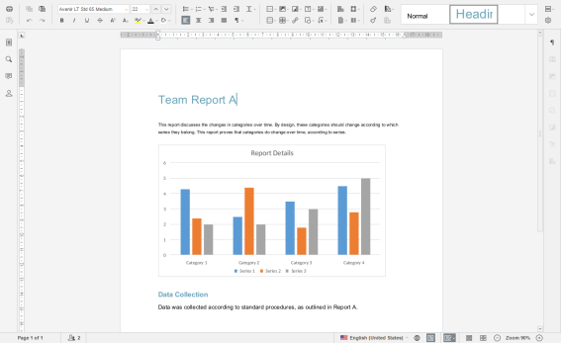
- In the Collaborative Web Editor, you can access a wide-range of formatting tools to help you update fonts, paragraph formats, charts, tables, images, style types, and more. Additionally, you can edit simultaneously with coauthors, send and receive chats, and view and manage comments.

Managing Content
- In the Files tab of the web portal, you can use the toolbar buttons to manage content in the selected folder.
  - Click the Create Folder button to create a new folder inside the web portal.
  - Click the Upload Files button to add files to the web portal.
  - Click the Rollback button to restore all files within the entire folder to an earlier revision before a selected date. The Revision Rollback feature is particularly useful in situations where a file might have been corrupted by ransomware; it utilizes a file’s revision history, and restores all currently-existing content in the folder to a healthy revision at a specified point-in-time. In these cases, you can use the Activity Log to determine when the infected revisions were uploaded, and then roll back files prior to the point of infection.
  - Click the Show Deleted button to show files that have been deleted.
  - Click the Restore Deleted button to return any deleted files to their original location.
  - Click the Erase all Revisions button to erase previous revisions.
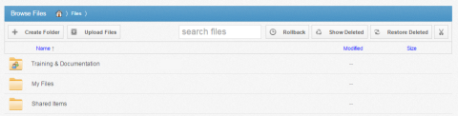
- Use the folder menu to manage individual folders;
  - Right-click a folder. A menu displays.
  - In the menu, you can:
  - Click the Download ZIP link to download the entire folder as a ZIP file to your local machine.
  - Click the Rename link to rename the title of the folder.
  - Click the Move link to change the path of the folder.
  - Click the Share link to share an individual link to the folder.
  - Click the Trim Revisions link to remove previous revision of the folder from the system.
  - Click the Delete link to delete the folder from the system.

Note: When you delete an item, it is still stored in the system for a pre-determined number of days. Within this timeframe, you can restore a deleted file. Please contact your administrator for more information.

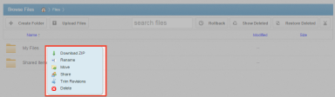
- Alternatively, you can use the file menu to manage individual files; or, press and hold down the Shift key to select multiple files at one time.
  - Right-click a file. A menu displays.
  - In the menu, you can:
    - Click the Download link to download the file to your local machine.
    - Click the Revisions link to view a list of revisions to the file, and optionally restore a previous revision.
    - Click the Activity link to review activity or events for the selected file.
    - Click the Rename link to rename the selected file.
    - Click the Move link to change the path of the selected file.
    - Click the Share link to share an individual link to the file.
    - Click the Erase Revisions link to remove previous revision of the file from the system.
    - Click the Delete link to delete the file from the system.

Note: When you delete an item, it is still stored in the system for a predetermined number of days. Within this timeframe, you can restore a deleted file. Please contact your administrator for more information.

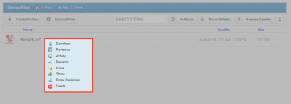

A Note about Excluded Extensions
While most of your files and folders will easily sync across all of your devices, certain system files and folders, as well as temporary application files, will not sync. Your administrator may have also configured other file extension types—such as application or video files—to be excluded from the syncing process.
You can add files with excluded extensions to Synced Folder, but they will not display in the web portal or in your mobile apps.
If you upload a file with an excluded extension through the web portal, you will receive a notification that the file is on the exclusion list. This file will not appear in the web portal or in your mobile apps.
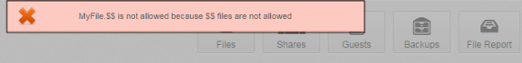
Live Databases
The system does not support the syncing of live database files, including Microsoft Access Databases, QuickBooks Files, .pst Files, and so forth. Attempting to sync a live database file could result in errors and collisions.

Mobile Apps
In addition to using the web portal or the desktop client on your local machine, you can manage files and folders from an app on your mobile device. Mobile app versions include Android, iOS, and Windows Phone.
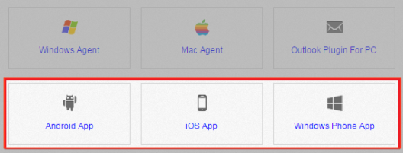

How to Download Mobile Apps
You can manage your files and folders from various mobile apps, including the Android app, the iOS app, or the Windows Phone app.
- Find and download the Android app in Google Play,
- Find and download the iOS app (for your iPhone or iPad) in iTunes, and
- Find and download the Windows Phone app in the Windows Phone site.
Alternatively, you can access a direct link to your device-specific app in the web portal.
To find your device-specific app:
- Click the Download App button in the web portal.
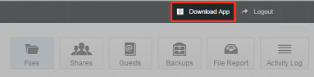
The Download page displays.
- In the Download page, select either the Android App, iOS App, or Windows Phone App button.
You will be redirected to the page that will allow you to download and install your device’s app.

How to Use the Android App
If you use an Android device, you can download the Android app in Google Play. The app allows you to
- View, rename, delete, and move content;
- Upload content from your device;
- Easily edit Microsoft Office content;
- Lock files and folders;
- Share files and folders (including secure shares);
- Automatically back up your photo gallery to a synced folder, called Camera Uploads; and
- Pin files so that they are fully downloaded on your device.
Logging In
To log in to your Android device:
- In your Android device, press the app icon to launch the app. The Login screen displays, prompting you to enter your credentials.
  - In the Host field, enter the host name of the system (for example, syncedtool.com).
  - In the User field, enter your username (for example, user@mail.com).
  - In the Password field, enter your password.
  - Press the Sign in button when you are finished.
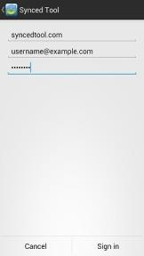
    - If Two-Step Authentication has been enabled for your organization or for your user account, you will be prompted to enter an authentication code at the time of initial registration. Enter the authentication code and press the OK button.
    - If Two-Step Authentication has been enabled for your entire organization, you will also be asked to configure a PIN after the initial registration process.

Note: If Two-Step Authentication has been turned on only for your user account (either by you or by your administrator) you will not be required to configure a PIN.

    - You will be directed to the Settings page. Select Require PIN.
You will be prompted to enter a PIN.
    - When accessing the mobile app in the future, you will be prompted to first enter this PIN.
Navigating
When you have access to your account, you can use the app to open, view, and manage content. For example:
- Press the My Files link to view and manage your files and folders; you can rename, move, or pin an item for offline viewing.
- Press the Recent Files link to view your most recent files.
- Press the Offline Files link to view a list of pinned files that can be viewed offline.
- Press the Backups link to view a list of your backups.
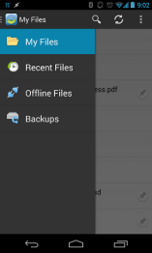
Viewing Files in the Web Preview Tool
You can view files using the Web Preview tool, which gives you the ability to preview content without fully downloading it to your mobile device. In this way, you can review content without utilizing mobile resources.
- Press the My Files link. The My Files screen displays.
- In the My Files screen, find the file that you want to view.
- Press the Preview icon.
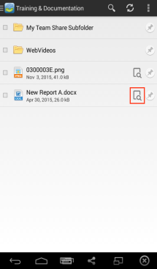
The file opens in the Web Preview tool, allowing you to review content without utilizing mobile resources.
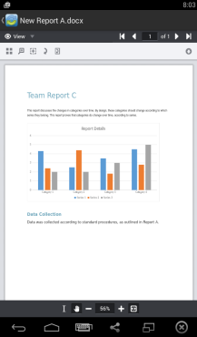
Locking a File or Folder
Optionally, you can lock a file or folder. To lock a file or folder:
- Press the My Files link. The My Files screen displays.
- In the My Files screen, select the file or folder within the Team Share that you want to lock.
- In the top right-hand corner of the screen, press the more options button, and then press the Lock link.
The file is now locked.
Editing Files and Folders
You can also edit files. To edit files:

Note: To edit content in your mobile app, you must first install a third-party editing tool. These instructions refer to Microsoft mobile apps (Microsoft Word app, Microsoft Excel app, and Microsoft PowerPoint app). You can download these tools at no cost. To use these tools for editing purposes, you must first create a free Office 365 account.

- Download the Microsoft Word app, Microsoft Excel app, or the Microsoft PowerPoint app, depending on your needs and preferences.
- With the Microsoft app installed, press the appropriate file that you want to edit.
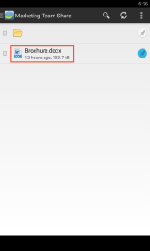
- The file will open in the Microsoft app, and will prompt you to sign in to your Office 365 account, if you are not already signed in. Press the Sign In button.
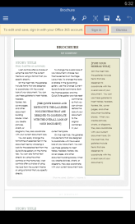
- The Office 365 Sign In page displays, asking you to either sign in or create a new account.
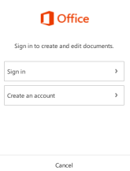
- When you are finished signing in, the file will display in the Microsoft app. Use the toolbar to edit the file as appropriate.
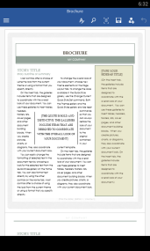
- Save your file when you are finished. The file will synchronize immediately.
Sending Share Links
You can also send share links directly from your mobile app. To send a secure or public share:
- Press the My Files link. The My Files screen displays.
- In the My Files screen, select the file or folder that you want to share, and press the Share button.
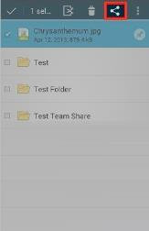
- In the Choose a share type window, select Public share to send a standard share. Alternatively, select Secure share to send a secure share, which will require the recipient to log in before he or she can access the shared item. Press OK to confirm your selection.

Note: If your administrator has configured settings to only allow secure shares, you will only have the option to send a secure share.

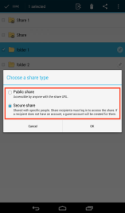
- In the Create a secure share window, enter your recipient's email address and press the OK button. Your item will be shared with the specified recipient.
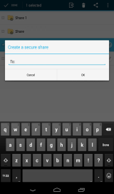
Backing Up the Gallery
You can also automatically back up your mobile phone's camera gallery to a synced folder using the Auto Backup feature. When this feature is turned on, your mobile app will automatically back up photos, videos, or both, to a synced folder called Camera Uploads. With this feature, you always have a backup of your mobile photos and videos.
- Press the Settings button. The Settings page displays.
- In the Settings page, press the Enable Auto Backup option.
- Press the Back Up Photos option to configure settings for backing up photos in your photo gallery:
  - Select Never if you don't want to back up your photos.
  - Select Over Wi-Fi Only to back up photos only when you are connected to Wi-Fi.
  - Select Over Wi-Fi or Mobile Network to back up your photos whether you are connected to Wi-Fi or on your mobile network. Please note that uploading over your mobile network will use your data connection, and charges from your service provider may apply.
- Press the Back Up Videos option to configure settings for backing up videos in your photo gallery:
  - Select Never if you don't want to back up your videos.
  - Select Over Wi-Fi Only to back up videos only when you are connected to Wi-Fi.
  - Select Over Wi-Fi or Mobile Network to back up your videos whether you are connected to Wi-Fi or on your mobile network. Please note that uploading over your mobile network will use your data connection, and charges from your service provider may apply.
- Press Back Up Now if you want to back up your photos and videos immediately, if allowed by your connection settings configured above.
Pinning Files for Offline Viewing
Finally, you can pin files so that they are downloaded to your device. Your mobile app will be aware of unpinned files, but only pinned files will be fully downloaded. You can decide to pin and unpin files based on space limitations and access needs.
- In the My Files screen, select the Pin button next to the file or folder that you want to download to your device. If you pin a folder, all if its files will be pinned as well.
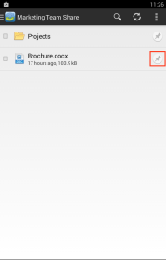
- When you unpin a file, it will remain on your mobile device until your cache is cleared. You can manually clear your cache through the Settings screen.

How to Use the iOS App
If you use an iOS device, such as an iPhone or an iPad, you can download the iOS app in iTunes. This app allows you to
- Open and view files and folders;
- Lock files and folders;
- Share files and folders;
- Send secure shares of files and folders;
- Upload content from your device, such as photos;
- Automatically back up your camera roll to a synced folder, called Camera Uploads;
- Rename, delete, and move items; and
- Favorite items for offline viewing.
Logging In
To log into the iOS app:
- In your iOS device, press the app icon to launch the app. The Login screen displays, prompting you to enter your credentials, including:
  - In the Host field, enter the host of the system (for example, syncedtool.com).
  - In the User field, enter your username (for example, user@mail.com).
  - In the Password field, enter your password.
  - Press the Login button when you are finished.
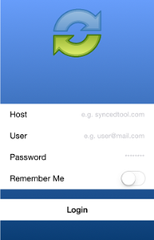
    - If Two-Step Authentication has been enabled for your organization or for your user account, you will be prompted to enter an authentication code at the time of initial registration. Enter the authentication code and press the OK button.
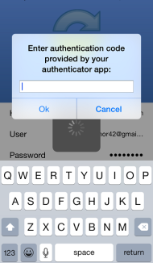
    - If Two-Step Authentication has been enabled for your entire organization, you will also be asked to configure a passcode after the initial registration process. At subsequent sessions, you will be prompted to enter this passcode when you access your mobile app.

Note: If Two-Step Authentication has been turned on only for your user account (either by you or by your administrator) you will not be required to configure a passcode.

      - You will be directed to the Settings page. Select Use Passcode.
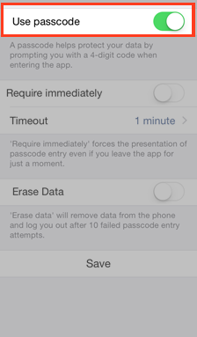
You will be prompted to enter a Passcode.
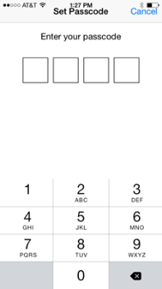
      - When accessing the mobile app in the future, you will be prompted to first enter this passcode.
Navigating
When you have access to your account, you can use the app to open and view files, manage files, and upload content. For example:
- Press the Files button to view and manage your files and folders; you can rename or move an item, or mark it as a favorite.
- Press the Backups button to view a list of your backups.
- Press the Favorites button to view a list of items that you have marked as favorites.
- Press the Upload button to upload content—such as images—from your phone to the server.
- Press the Settings button to view your account information, such as the app revision, your user name, space usage, passcode lock settings, and local storage settings. You can also turn on the option to only upload content over a wifi connection.
Viewing Files in the Web Preview Tool
You can view files using the Web Preview tool, which gives you the ability to preview content without fully downloading it to your mobile device. In this way, you can review content without utilizing mobile resources.
- Press the Files button. The Files screen displays.
- In the Files screen, find the file that you want to view.
- Press the title of the file. The file opens in the Web Preview tool, allowing you to review content without utilizing mobile resources.
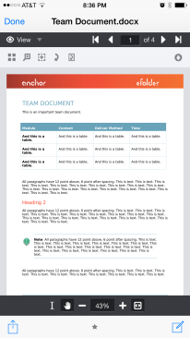
Locking Files and Folders
Optionally, you can lock a file or folder within a Team Share. To lock a file or folder:
- Press the Files button. The Files screen displays.
- In the Files screen, press the Edit link at the top right-hand corner of the screen.
- Select the appropriate file or folder, and then press the Lock button at the bottom of the screen. The item is now locked, preventing other users from accessing your content.
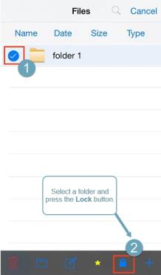
Editing Files and Folders
You can also view and edit files using a third-party application. To view and edit files:
- Press the Files button. The Files screen displays.
- In the Files screen, select the file you want to edit.
- While inside the file, press the Share button at the bottom of the screen.
- In the Share menu, press the Open In link, and then select a third-party file editing application. You can edit the file in the third-party application.
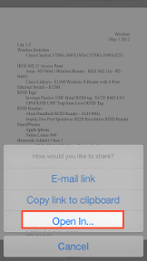
Sharing Files and Folders
You can also share files and folders directly within your app. To share a file or folder, or to send a secure share:
- Press the Files button. The Files screen displays.
- In the Files screen, find the file or folder that you want to share and slide it to the right. Press the Share button.
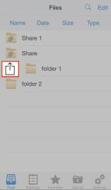
- To send a share link, press the E-mail link option. Alternatively, to send a secure share, press the E-mail secure link option.

Note: If your administrator has configured settings to only allow secure shares, you will only have the option to send a secure link.

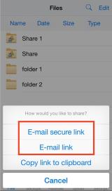
You will be prompted to select a recipient and compose an email message.
Backing Up the Camera Roll
You can also automatically back up your mobile phone's camera roll to a synced folder using the Auto Backup feature. When this feature is turned on, your mobile app will automatically back up photos, videos, or both, to a synced folder called Camera Uploads. With this feature, you always have a backup of your mobile photos and videos.
- Press the Settings button. The Settings page displays.
- In the Settings page, press the Enable Auto Backup option.
- Press the Back Up Photos option to configure settings for backing up photos in your camera roll:
  - Select Never if you don't want to back up your photos.
  - Select Over Wi-Fi Only to back up photos only when you are connected to Wi-Fi.
  - Select Over Wi-Fi or Mobile Network to back up your photos whether you are connected to Wi-Fi or on your mobile network. Please note that uploading over your mobile network will use your data connection, and charges from your service provider may apply.
- Press the Back Up Videos option to configure settings for backing up videos in your camera roll:
  - Select Never if you don't want to back up your videos.
  - Select Over Wi-Fi Only to back up videos only when you are connected to Wi-Fi.
  - Select Over Wi-Fi or Mobile Network to back up your videos whether you are connected to Wi-Fi or on your mobile network. Please note that uploading over your mobile network will use your data connection, and charges from your service provider may apply.
- Press Back Up Now if you want to back up your photos and videos immediately, if allowed by your connection settings configured above.
Setting a File or Folder as a Favorite for Offline Viewing
Finally, you can mark files and folders as a favorite so that they are downloaded to your device. Your mobile app will be aware of files that are not favorites, but only favorite files and folders will be fully downloaded. You can decide to favorite and unfavorite files and folders based on space limitations and access needs.
- In the Files screen, slide the appropriate file or folder to the right to reveal a set of options for that file or folder.
- Press the Favorite button (star icon) to mark the file as a favorite. If you favorite an entire folder, all if its files will become favorites as well.
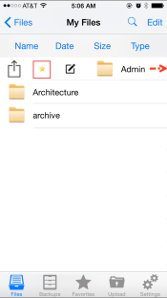
- To a view a full list of favorite files and folders, press the Favorites button.

How to Use the Windows Phone App
If you use a Windows Phone, you can download the Windows Phone app in the Windows Phone store. The app allows you to view and manage files directly on your Windows Phone device.
To use the Windows Phone app:
- In your Windows Phone, press the app icon to launch the app. The login window displays, prompting you to enter your credentials, including:
  - In the Host field, enter the host of the system (for example, syncedtool.com).
  - In the User field, enter your username (for example, user@mail.com).
  - In the Password field, enter your password.
- When you have access to your account, you can use the app to manage content. For example:
  - Press the Files link to view and manage your files.
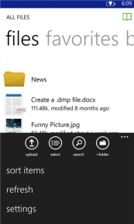
  - Press the Favorites link to view a list of your favorite items.
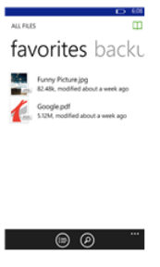
  - Press the Backups link to view a list of your backups.
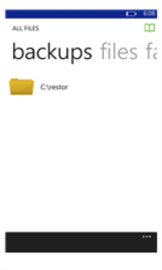

The Desktop Client for Windows and Mac Machines
In addition to using the web portal and mobile apps, you can also manage files and folders from your computer (local machine) using the desktop client.
The desktop client includes a folder, called Synced Folder, which stores your files and folders on your local machine. Files and folders that are added to Synced Folder will automatically sync to the web portal and any other devices you have connected to your account. You can use the desktop client on both Windows and Mac machines.

How to Download the Desktop Client
When you download and install the desktop client, you can access your files and folders directly on your computer (local machine).
To download the desktop client on a Windows or Mac machine:
- Click the Download App button in the web portal.
The Download page displays.
- In the Download page, select either the Windows Desktop Client or Mac Desktop Client button. The selected file will start to download, or you will be prompted to save the file, depending on your browser type.
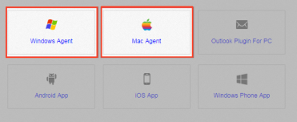
- When the file finishes downloading, click the installation file to launch the Setup Wizard.
- Click the Next button to start the Setup Wizard.
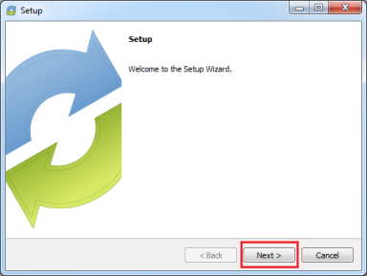
- In the License Agreement screen, click the I accept the agreement radio button if you accept the license. Then, click the Next button to continue.
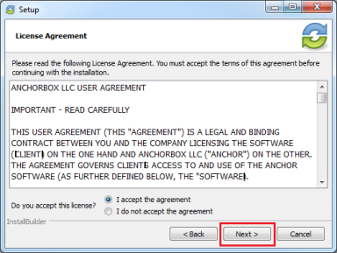
- In the Installation Directory screen, select the location where you want the installation files to reside on your local machine. In most instances, you can accept the default location. Click the Next button to continue.
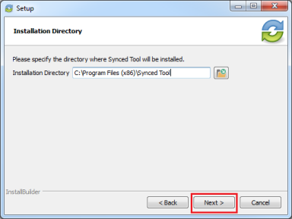
- In the Ready to Install screen, click the Next button to begin the installation process.
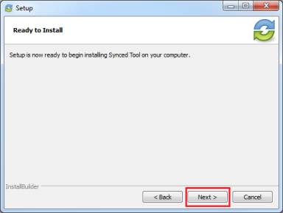
- When the Setup Wizard completes, you can optionally click the Create a Desktop Shortcut checkbox. Then, click the Finish button.
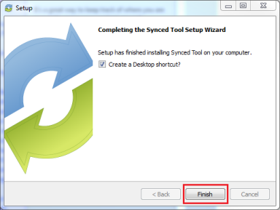

How to Register the Desktop Client
After the desktop client is installed, it must be registered to your user account so that it can recognize the files and folders that belong to you.
To register the desktop client on a Windows or Mac machine:
- After the Setup Wizard completes, the Registration Wizard will automatically launch. Alternatively, click the icon on your computer’s system tray or menu bar, and select Register. The Registration Wizard displays.

Note: On a Windows machine, the icon is located in the lower right-hand corner of the screen; on a Mac machine, the icon is located in the upper right-hand corner of the screen.

- Click the Next button to continue.
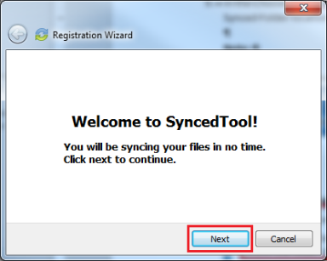
- In the Login screen, enter your login credentials as provided by your administrator. Click the Next button to continue.
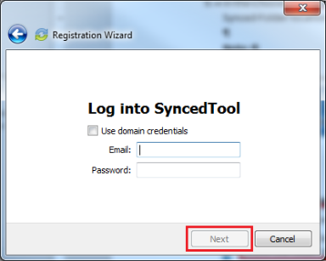
  - If Two-Step Authentication has been enabled for your organization or for your user account, you will also be prompted to enter an authentication code at the time of initial registration.
  - After you receive your authentication code, enter the authentication code and press the OK button.
- In the Choose Setup Type screen, select either a typical or advanced installation path for synced files, where all files, folders, and shares can be accessed on your local machine. When you select a typical path, Synced Folder can be accessed in the following location: C:\Users\[User Name]\Synced Folder. In most instances, you can select the Typical radio button. Click the Next button to continue.
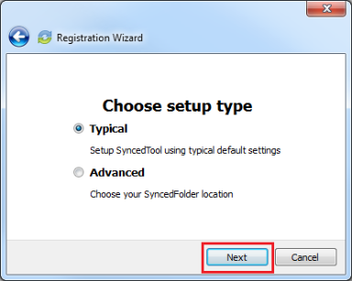
- In the Choose your Synced Folder location screen, click the Change button to specify another location on your local machine. Click the Next button when you are finished.

Note: A folder named Synced Folder will automatically be created within the location you select. You do not need to manually create a folder titled, Synced Folder.

In some cases, if you have previously installed using the same settings, you will receive a warning message indicating that a folder already exists. Click the OK button to merge with the existing folder, and then continue with the Registration Wizard.
- In the Selective Sync screen, click the Sync Everything to this Machine radio button to sync down all Team Share content and personal folders currently available in the cloud. Or, click the Customize radio button to deselect content that you do not want on your local machine. You can always change these settings in the desktop client's Properties dialog box after registration is complete.
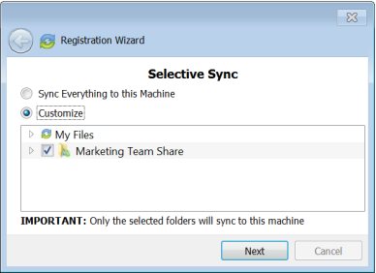
- Click the Finish button when the Registration Wizard completes.

How to Upload Files in the Desktop Client
When files and folders are added to the web portal, they automatically propagate down to your local machine; you can then find these files and folders inside your Synced Folder. In the same way, files and folders that are added to Synced Folder will automatically sync to the web portal and any other devices you have connected to your account. You can use the desktop client on both Windows and Mac machines.
To upload files in the desktop client on a Windows or Mac machine:
- On your computer (local machine), open Synced Folder in an explorer window. Synced Folder displays.
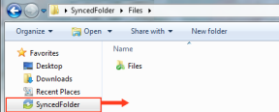
- Drag files or folders into Synced Folder. Alternatively, you can save files to Synced Folder directly from the application in which you are working (for example, Microsoft Word).
- Use the icons to understand when your files are syncing. For example:
  - A blue icon on a file indicates that the file or folder is currently syncing.
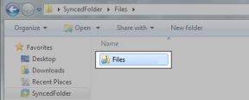
  - A green icon means that the file or folder has successfully synchronized, and is available in the web portal and on your mobile devices.
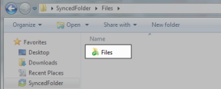

How to Manage Preferences for the Desktop Client
Using the icon on your computer's system tray, you can manage preferences, pause a sync process, and view warning messages.
Managing Preferences
To manage your preferences, or to change your settings:
- Click the system tray icon and select Properties. The Preferences dialog box displays, showing the General tab.
- Use the General tab to view or change status or settings.
  - The sync status message area shows the current state of the sync process, including whether the files are up to date, pending sync, or currently syncing.
  - The space status bar shows how much space has been allotted to your account, and how much is being used.
  - The Device Account info area shows account details, and also allows you to unlink, or unregister, your machine.
  - The Notification Options area allows you to configure notification settings, including whether or not you want to hide your desktop icon, or hide notifications.
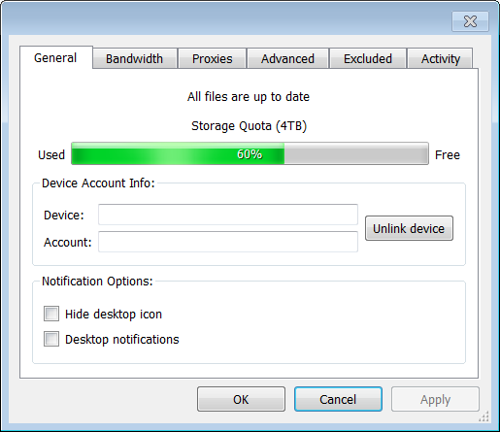
- Click the Bandwidth tab to configure how fast content is uploaded to the server, or to configure LAN Sync.
When managing bandwidth settings, you have the option to set a specific limit, or decide not to limit bandwidth. Please note that administrator settings might override your personal settings.
If you are working within a Local Area Network (LAN), you can optionally turn on LAN Sync. LAN Sync refers to a file synchronization approach that accelerates the sync process when a shared file already exists on a LAN. If you have questions about this setting, please contact your administrator.
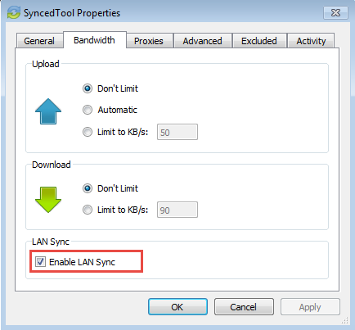
- Click the Proxies tab to configure proxy settings for your network. You may select from:
  - No proxy, which indicates that proxy settings are not set.
  - Detect Automatically, which auto-detects proxy settings from your system or network.
  - Custom, which allows you to apply custom proxy configurations if you are unable to automatically have the system detect your proxy server settings. If you select this option, you must configure the Proxy Type, the Server, the Port, and a Username and Password.
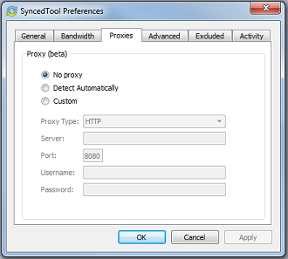
- Click the Advanced tab to monitor locally available roots, to set Auto-Locking preferences, to specify a preferred language, and to manage remote browsing settings.
  - Use the Sync Folders section to view a list of Team Shares and backups available on your local machine. This section lists the path to each item, along with its health status, including:

OK | The folder is syncing as expected.
Deleted | The folder has been deleted.
Missing | The drive is missing.
Login Failed | Network path credentials are invalid.
Mounting | The network path is being mounted.

You can also use the side toolbar to manage each item, including:

The Open Folder button opens the currently selected folder. This button is only enabled if the folder is available and currently syncing.
The Unlink Folder button unlinks a selected Team Share or backup, or it unregisters the machine if the top level path is selected. This button is enabled for all path types, except mounted paths.
The Sync Down button recreates or resyncs a deleted Team Share. This button is only active if the selected Team Share has been unexpectedly deleted from the local machine.
The Enter Credentials button prompts the user to reenter invalid credentials. This button is only active if the selected item is a network path that cannot be mounted due to invalid credentials.

  - Click the Selective Sync button to select and deselect the Team Shares, personal folders, and subfolders that you do not want available on your local machine.
  - Click the Language drop-down menu to select your preferred language.
  - Click the Auto Locking drop-down menu to set your preferred auto-locking preference. If your administrator has turned on the Auto-Locking for Word and Excel feature for a Team Share, you can decide to automatically lock, never lock, or receive a prompt each time you open a Word or Excel file in a Team Share.
  - Click the Disable Remote Browsing checkbox to prevent administrators from remotely browsing the contents of your Synced Folder (for example, to create a backup of your local folders).
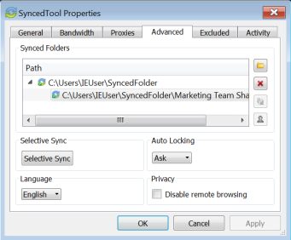
- Click the Excluded tab to view a list of files that are being excluded from the sync process, and why they are being excluded. For example, a file might be excluded based on the file type.
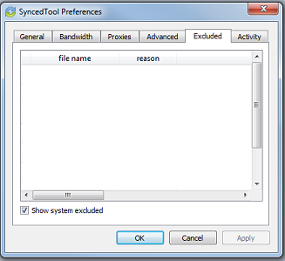
- Click the Activity tab to view the activity between the desktop client and the server.
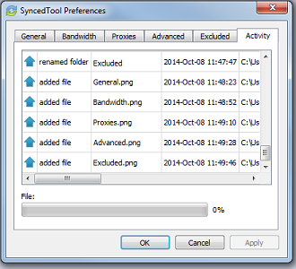
Pausing a Sync Process
You may find times when you would like to pause the sync process, such as when you are getting on a plane, when you want to conserve bandwidth, or if you would like to work in isolation.
To pause a sync process on a Windows or Mac machine:
- Click the icon on your computer’s system tray or menu bar, and select Pause Sync.

Note: On a Windows machine, the icon is located in the lower right-hand corner of the screen; on a Mac machine, the icon is located in the upper right-hand corner of the screen.

The Pause Sync option will appear with a checkmark next to it, and will remain paused until this setting is unchecked.
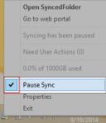
- To resume the sync process, click the icon on your computer’s system tray or menu bar, and select Pause Sync again. The Pause Sync option will no longer display a checkmark, and the sync process will resume.
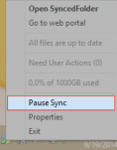
Viewing Warning Messages
In addition to managing preferences and pausing a sync process, you can view the desktop client warning messages and resolve issues directly from the system tray icon.
- Click the icon on your computer’s system tray or menu bar. The system tray menu displays, allowing you to view and manage warning messages.

 | The Sync Status indicator message displays the status of your desktop client's sync process. | 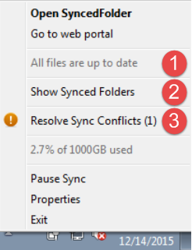
 | The Show Synced Folders link opens the Advanced tab of the desktop client's Properties dialog box, allowing you to manage roots that exist on your local machine.
 | The Resolve Sync Conflicts message activates when a file sync conflict—such as a collision or a locked file revision—occurs on your local machine. When this link is active, click the link to resolve the file sync conflict. For more information, please reference the How to Resolve File Sync Conflicts section of the End User Guide.

How to Use the Selective Sync Feature
The Selective Sync feature gives end users the ability to select the content that syncs down to their local machines. While all content is still accessible in the web portal, end users can control the amount of data that is downloaded and stored locally, reducing local storage and bandwidth requirements, and increasing options on where and how they access content.
To use the Selective Sync feature:
- Click the system tray icon and select Show Synced Folders. The Properties dialog box displays, showing the Advanced tab.
- Click the Selective Sync button.
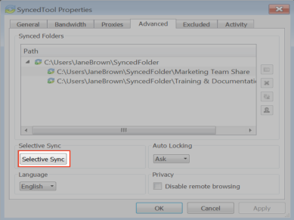
- In the Selective Sync pop-up window, click to expand individual Team Shares to select or deselect Team Share roots or Team Share subfolders. Alternatively, click to expand My Files to select or deselect personal folders.
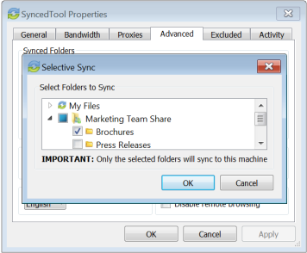
- Click the OK button when you are finished selecting and deselecting content. A confirmation dialog box will display, notifying you that only the selected items will sync down to your machine. All other folders will still be available in the web portal, and on any other device that can selectively sync content.
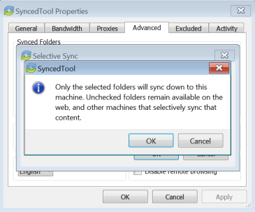
- Click the OK button to confirm these changes. The desktop client will resync as appropriate.

How to Add the Desktop Client as a Storage Location in Microsoft Office
You can add the Desktop Client as a storage location in Microsoft Office, making it easy for you to open, edit, and save Microsoft Office-supported content stored in the cloud. When you sign in to either a Microsoft account or a Microsoft Office 365 account, you can:
- Open and save local content stored in the cloud, without navigating away from your local application
- View a list of your recently opened cloud content, allowing you to quickly access your most relevant content supported by the Microsoft application
- Retrieve this storage location on all of your registered machines when you sign in using the same Microsoft or Microsoft Office 365 account
In this way, you can personalize your Microsoft Office experience by accessing your synced Microsoft Office files from all of your registered machines.
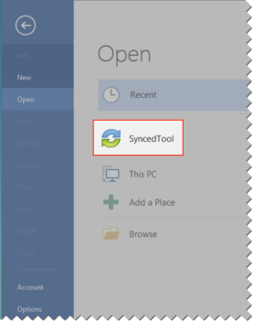

Note: This feature is supported for Microsoft Office revision 2013 and higher.

Adding The Desktop Client as a Storage Location
Before you can begin using this feature, you must add the desktop client as a storage location in your Microsoft Office local applications.
- Open a Microsoft Office application on your local machine and click the Open Other Documents link.
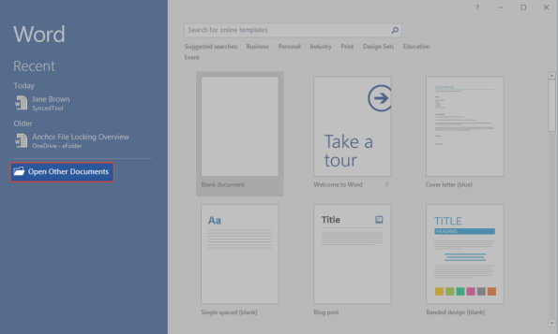
The Open section of the Microsoft Office backstage area displays, prompting you to open a file.
- In the backstage area, click Add a Place. A list of available storage locations will display on the right-hand side of the backstage area.
- Select the desktop client from the list of available storage locations.
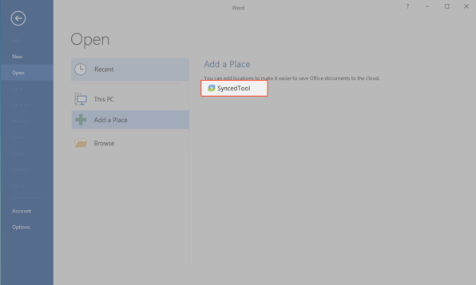
- You can now open files, edit files, and save new files to the desktop client directly from your Microsoft Office application.
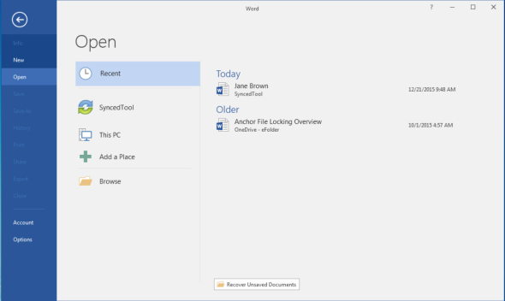
Accessing Cloud Content from Other Instances of Microsoft Office Applications
If you have Microsoft Office installed on more than one computer, but you have not yet installed the desktop client on each machine, Microsoft Office will prompt you to install the desktop client.
- Open a Microsoft Office application on your local machine and click the Account link. The Account section of the backstage area displays, allowing you to manage your account information.
- If you have not already signed in to your Microsoft or Microsoft Office 365 account, click the Sign In button.
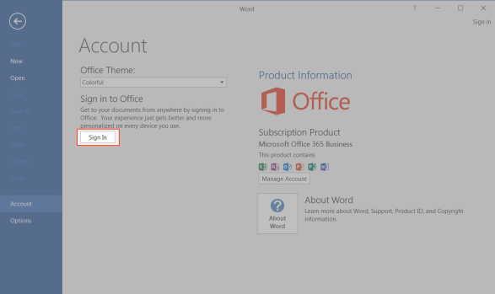
- When you are signed in, you will see a warning message if you do not have the desktop client service installed.
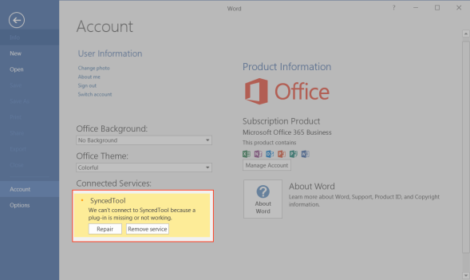
- Click the Repair button. A browser window will open, prompting you to download and install the desktop client. When the desktop client is installed, you can access your synced content from within your local Microsoft Office applications.
Removing the Desktop Client as a Storage Location
- Open a Microsoft Office application on your local machine and click the Account link. The Account section of the backstage area displays, prompting you to manage your user information.
- In the backstage area, find the desktop client, and click the Remove link.
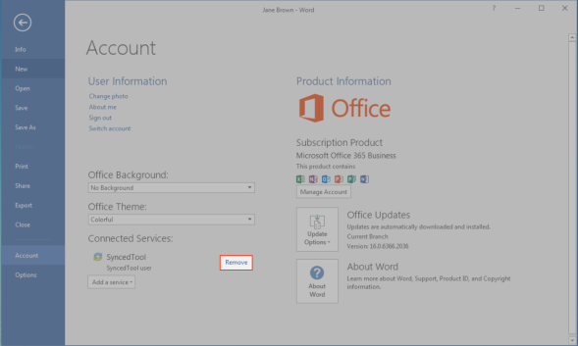
A dialog box displays, prompting you to confirm your selection.
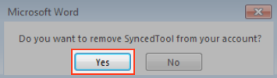
- Click Yes to confirm your selection. The desktop client will be removed as a storage location.

Sharing and Collaborating
You can collaborate and share files in many ways.
- A Team Share is a shared folder that can be accessed by groups of users. Team Shares can be configured for users in your organization. When you work within Team Shares, it is important to be careful and courteous when you edit, delete, and move files and folders. Files and folders stored in Team Shares are shared among all other subscribers, so what you do affects your team members.
- A share link allows you to share a direct link to a file or folder, rather than sharing an entire area. Share links can be configured for users in your organization and outside of your organization. You can send a public share to recipients inside or outside of your organization; alternatively, you can send a secure share, which requires login credentials. If you send a secure share to a recipient outside of your organization, the system will create a guest account for that user.
With both Team Shares and share links, you can share files and folders in the web portal, in the desktop client, or mobile apps.
Additionally, with the real-time Collaborative Web Editor, you can edit documents, spreadsheets, and presentations when working in the web portal, without needing to download a separate application or navigate away from the system.

How to Create a New Team Share
Your administrator might have created Team Shares for you when the system was first configured, but you can also create your own Team Shares. You can create a Team Share if you are collaborating with another person, or group, on a specific set of content. You add files to Team Shares the same way you add files to standard folders. When you or another user in your Team Share adds or edits a file or folder, changes synchronize across all subscribed accounts.
In both the web portal and in Synced Folder, Team Share folders can be recognized by icons with two people on it.
- Team shares in the web portal:
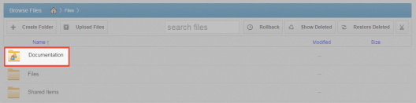
- Team shares in Synced Folder:
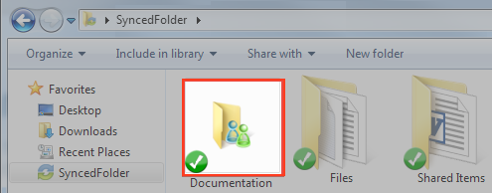
When you work within Team Shares, it is important to be careful and courteous when you edit, delete, and move files and folders. Files and folders stored in Team Shares are shared among all other subscribers, so what you do affects your team members.
You might find it useful to follow certain best practices to ensure that shared content is protected and well managed. These best practices include:
- Locking files and folders before you begin making changes—when you lock a file and folder, you are essentially setting it as read-only for others subscribed to the Team Share, giving you exclusive editing rights while you make changes. For more information, please reference the Locking Files and Folders section of the Anchor Administrator Guide.
- Monitoring activity using the File Report, the Activity Log, and the Daily Email Digest—To see a summary of changes made to files and folders within a specific Team Share, you can optionally track and monitor activity in the web portal using the File Report and the Activity log. For more information, please reference the File Report and Activity Log section of the Anchor Administrator Guide. To create a Daily Email Digest that summarizes activity for a particular Team Share, please reference the How to Manage Shared Items section of the Anchor Administrator Guide.
To create a new Team Share:
- In the web portal, click the Shares tab. The Team Shares page displays.
- In the Team Shares page, click the Create Team Share button.
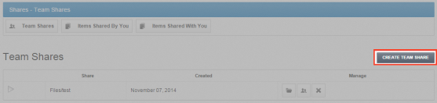
The Create Team Share page displays.
- In the Create Team Share page, type a descriptive name for the Team Share in the Team Share Name field.
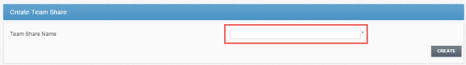
- Click the Create button when you are finished. You will be redirected to the Team Share Subscribers page.
- In the Team Share Subscribers page, select a name from the Select a User drop-down menu, and click the Add to Share button.
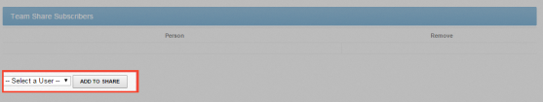
The selected user will now be added to the Team Share.

How to Send Share Links in the Web Portal
You can share links to files directly with third parties, without using Team Shares. You can share files and folders with users in your organization and outside of your organization.
To send a share link from the web portal:
- Right-click the file or folder and select Share.
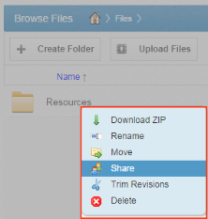
A Share Access dialog box displays.
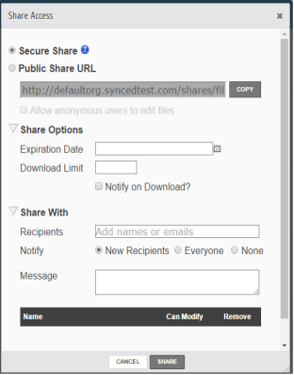
- In the Share Access dialog box, configure settings for sharing the link, including:
  - The Secure Share option, which sends password-protected share links to items.
  - The Public Share option, which sends standard share links to items. If you create a public share link, you can also click the Allow anonymous users to edit files radio button to allow recipients to edit the file online using the Collaborative Web Editor.
  - The Share Options settings, which allow you to select whether the share link will expire after a certain date, if each recipient should be limited to the number of times the item can be downloaded, and if you would like to be notified through email when the share is downloaded. If you are sharing an entire folder, you can also select to receive a notification when an item is uploaded to the shared folder.
  - The Share With settings, which allow you to specify share recipients and set permissions for each of these users. This section is only required if you are sending a secure share link.
  - The Permissions settings, which let you set Can Modify permissions, allowing the specified user to edit the file using the Collaborative Web Editor. If you are sharing an entire folder, Can Modify also allows users to upload files into the folder. Additionally, you will be able to set Can Delete permissions, allowing the user to delete files within the shared folder.

How to Send Share Links in the Desktop Client
In addition to sharing files and folders with guests in the web portal, you can also share items directly from your local machine.
To send a share link from a Windows or Mac machine:
- Right-click a file or folder, point to the sync menu, and select Share link.
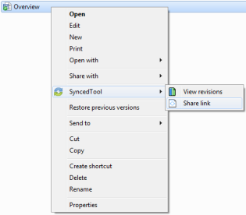
The Share Access dialog box displays, allowing you to configure settings the same way as you would from the web portal.
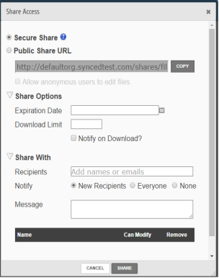
- In the Share Access dialog box, configure settings for sharing the link, including:
  - The Secure Share option, which sends password-protected share links to items.
  - The Public Share option, which sends standard share links to items. If you create a public share link, you can also click the Allow anonymous users to edit files radio button to allow recipients to edit the file online using the Collaborative Web Editor.
  - The Share Options settings, which allow you to select whether the share link will expire after a certain date, if each recipient should be limited to the number of times the item can be downloaded, and if you would like to be notified through email when the share is downloaded. If you are sharing an entire folder, you can also select to receive a notification when an item is uploaded to the shared folder.
  - The Share With settings, which allow you to specify share recipients and set permissions for each of these users. This section is only required if you are sending a secure share link.
  - The Permissions settings, which let you set Can Modify permissions, allowing the specified user to edit the file using the Collaborative Web Editor. If you are sharing an entire folder, Can Modify also allows users to upload files into the folder. Additionally, you will be able to set Can Delete permissions, allowing the user to delete files within the shared folder.

How to Manage Guest Accounts
Guests are special accounts that are created for individuals outside of your organization. You can manually create a guest account and give that guest access to files and folders; you can even give a guest access to an entire folder so that the guest can upload and manage content within the system.
Alternatively, if you send a secure share invitation to a person outside of your organization, you are automatically creating a guest within the system. You can manage your guest accounts using the Guests tab inside the web portal. For example, you might want to remove guests who no longer need access to content that you have shared.
Guest users can also manage their own user settings—including their name, email address, and password—and can even delete their own account.
Specifically, Guest accounts can:
- Access a shared file or folder through the web portal
- Manage their account information and change their password
Guest accounts cannot:
- Utilize the desktop desktop client, WebDAV, or mobile apps
- Subscribe to Team Shares

Best Practice: If you will be collaborating with a guest account on a regular basis, you might consider sharing an entire folder with the guest account. When you create a secure share to a folder, you can invite a guest account and decide whether or not to give that guest account permission to upload or delete content from that shared folder. You can also choose to be notified when the guest user uploads or downloads content. In this way, the shared folder becomes a collaborative space where you can exchange and review content.

To manage guest accounts:
- In the web portal, click the Guests tab. The Guests page displays, listing all of your existing guests.
- Use the tools in the Guests tab to manage guests.
  - The Create Guest button, which allows you to manually add a new guest. You can configure the guest's name, email address, password, and even decide if and when the password should expire.
  - The Remove button, which allows you to delete an existing guest.
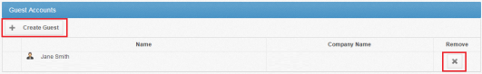

How to Manage Shared Items
You might find it useful to keep track of items in Team Shares, as well as items you have shared with third parties. Using the Shares tab in the web portal, you can generate and view reports that allow you to manage these shared items.
To track shared items:
- In the web portal dashboard, click the Shares tab to manage your shares.
- Click the Team Shares button to access controls that allow you to create, view and edit Team Shares.
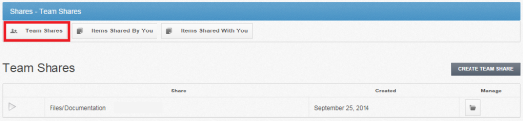
  - Optionally, click the arrow to expand a Team Share.
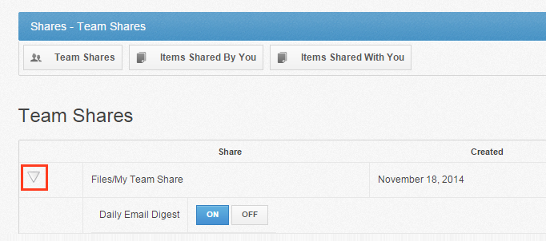
  - Click the On button to receive a Daily Digest email for the selected Team Share. A Daily Digest email will outline detailed information about events that occurred within the Team Share. You will receive a daily email until you turn off the Daily Digest option.
  - You can also turn on or off the syncing of Team Share content down to your local machine. This functionality is useful if a Team Share contains large files (such as video files) and you would rather only access the content when necessary from the web. Click the Off button to turn off the syncing of content to your local machine. Alternatively, click the On button to ensure that all content gets synchronized to your local machine.
- Click the Items Shared By You button to track how many times an item you shared has been viewed, downloaded, and whether or not it is set to expire on a certain date. You can also click the arrow to expand an item, which allows you to view detailed information about the user that received your shared item.
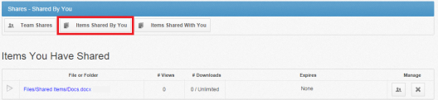
- Click the Items Shared With You button to view files that were shared with you by others in your organization, as well as information about who shared the file and what access rights you were given (including read, write, and delete).
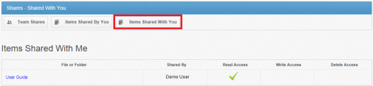
- Finally, in some instances, you might be invited to join a Team Share that is outside of your standard work organization. When this happens, you will be alerted through email and by a notification in the Shares tab of the web portal. Use the Shares tab to accept or decline this invitation.
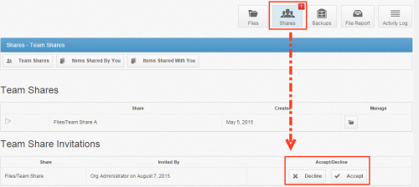

How to Edit Files in the Web Portal Using the Collaborative Web Editor
With the real-time Collaborative Web Editor, you can edit documents, spreadsheets, and presentations when working in the web portal, without needing to download a separate application or navigate away from the system. Additionally, the Collaborative Web Editor allows you to make these changes simultaneously with multiple coauthors, and lets you see each edit in real time.
Advanced functionality includes:
- Access a wide range of formatting tools to help you update fonts, paragraph formats, charts, tables, images, style types, and more
- Edit simultaneously with coauthors and view their changes in real time
- Send and receive instant chat messages
- Add, view, and manage changes and comments

Revisions
- Files automatically save ten seconds after the latest edit.
- For security purposes, an editing session will end after one hour of inactivity.
- Editing a file within the Collaborative Web Editor will generate a revision in Anchor.

Anonymous Editing Permissions
When sharing a file, users can grant anonymous editing permissions on public share links. Anonymous editing permissions allow anyone with access to the share link to edit the file using the Collaborative Web Editor.

Notifications and File Locking
- In the Web Portal, a file that is being actively edited from within the Collaborative Web Editor will be marked with a Web Edit icon. Team Share subscribers will still be able to launch this file from the web portal using the Collaborative Web Editor.
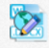
- In the desktop client, a file that is being actively edited from within the Collaborative Web Editor will be automatically protected by the File and Folder Locking feature and marked with a lock icon. Team Share subscribers will not be able to edit this file using applications on their local machines.
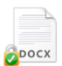

Launching the Collaborative Web Editor
To use the Collaborative Web Editor:
- In the Files tab of the web portal, navigate to the file that you want to edit.
- Right-click the file and select Edit.
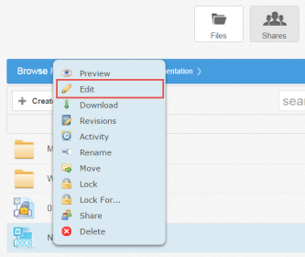
The file opens in the fully integrated, real-time Collaborative Web Editor.
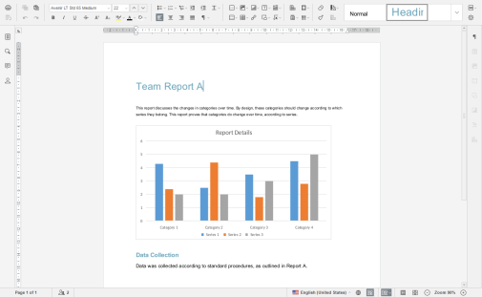
- To configure advanced settings, click the Manage button.
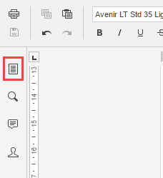
The left-hand navigation bar expands.
- In the left-hand navigation bar, click the Advanced Settings link to turn on and off features, such as commenting, spell check, auto-save, and so forth. You can also choose to view or disable real-time collaboration changes.
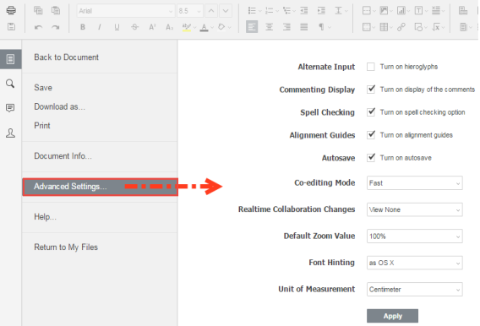
- While still in the Files section of the tool, you can:
  - Click Save to save the file.
  - Click Save as to save the file with a new name.
  - Click Share Link to generate a share link for a standard user or guest user. The recipient will be given privileges to co-edit the document using the Collaborative Web Editor.
  - Click Download as to download the file to your local machine. You will be presented with the option to download the file in your preferred file format.
  - Click Print to print the document using your preferred printing device.
  - Click Help to view a comprehensive listing of all available functionality.
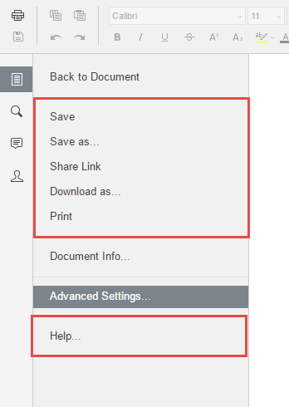
- Click the Back to Document link to collapse the left-hand navigation menu.

Inviting Coauthors to Collaborate
To collaborate on a single file in real time, you can create a share link from the web portal or your desktop client. You can also invite users to collaborate from within the Collaborative Web Editor.
- Click the File tab and select Share Link.
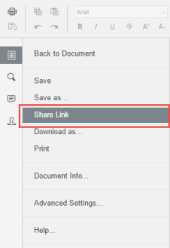
The Share Access dialog box displays.
- You can create a public share link to allow anonymous users to edit the file:
  - Select the Public Share URL radio button, and then click the Copy button to ensure that you capture the URL of the file.
  - Select the Allow anonymous users to edit files checkbox to let anyone who launches the share link to edit the file using the Collaborative Web Editor.
  - Click the Share button to save your settings. You will then be able to paste the share link in an email, chat, or other messaging device.
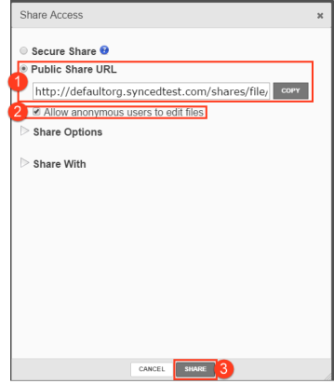
- Alternatively, you can create a secure share link to require recipients to log in:
  - Select the Secure Share radio button.
  - In the Recipients field, enter the name of the coauthor. The name of this new user will display in the lower portion of the screen.
  - Ensure the Can Modify checkbox is selected. The Can Modify permission allows this user to edit the file.
  - Click the Share button to send the share invitation to the recipient(s).
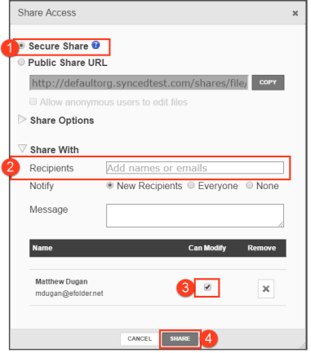
- To view a list of coauthors, click the View Users button. A pop-up window displays, showing a list of users who are actively editing the document.
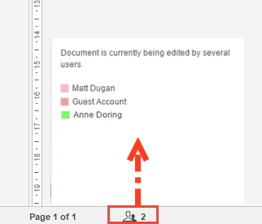
When these users make changes, their edits are visible immediately and are marked with a vertical bar.
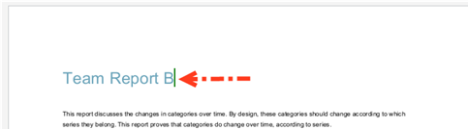
- Hover over the vertical bar to view editing details.
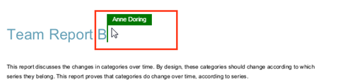

Chatting with Coauthors
When you are collaborating on a document in real time, you can use the Chat feature to communicate and share ideas with coauthors.
- In the left-hand navigation bar, click the Chat button to reveal the chat window.
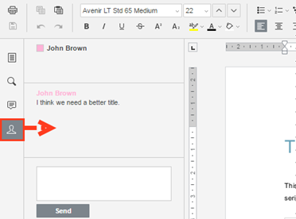
- Enter your message in the Chat dialog box and click the Send button. A visual overlay displays over the recipient's Chat button, indicating that a new message is available to view.
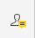

Editing with Coauthors
The Collaborative Web Editor allows you to edit using its Track Changes feature. You can also embed comments into files to aid in the collaboration process.
Note: If the file is later downloaded and opened on a local machine, these edits and comments will remain, and will display in all applications that support Track Changes and commenting (for example, Microsoft Office products).
- To turn on Track Changes, click the Track Changes button found at the bottom right-hand corner of the screen.
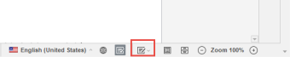
All changes made by you and coauthors will display in bubbles, allowing other users to accept or reject these changes.
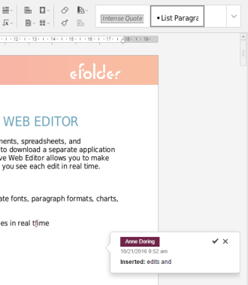
- To add a comment, highlight the appropriate portion of the file, right-click the highlighted content, and then select Add Comment.
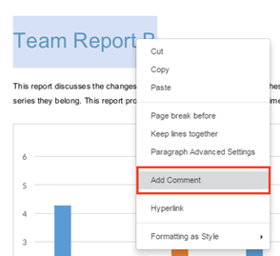
A pop-up bubble displays, allowing you to type a comment.
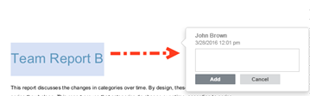
- To view all comments in the document, or to respond to an existing comment, click the Comments button in the left-hand navigation bar. You can use the toolbar to edit, delete, or mark a comment as resolved.
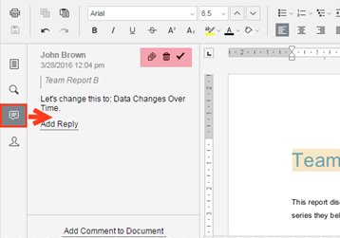

Locking Files and Folders
File locking allows users to place locks on files and folders in Team Shares. This feature is useful when you want to prevent other user accounts from editing your items when you are making changes, which prevents file sync conflicts. You can place locks on a whole Team Share, a subfolder in a Team Share, or a file in a Team Share. When an item is locked, a lock icon will be placed over the file or folder, and it will become read-only for others subscribed to the Team Share.
If you forget to lock a file or folder before you begin making changes, you could encounter file sync conflicts. A file sync conflict might take the form of a collision, where two Team Share subscribers try to edit the same file at the same time, or a locked file revision, where a user attempts to edit a locked file. When a file sync conflict occurs, the system will notify you of the conflict, and will help you resolve the issue.
Your administrator can configure a Team Share so that Microsoft Word and Excel Team Share files automatically prompt you to lock the files each time they are opened. When you confirm the lock, the files will automatically unlock when you close the file.

How to Lock Files and Folders in the Web Portal
In the web portal, you can place locks on a whole Team Share, a subfolder in a Team Share, or a file in a Team Share. When an item is locked, a lock icon will be placed over the file or folder, and it will become read-only for others subscribed to the Team Share.
To place a lock on a file or folder in the web portal:
- In the web portal, right-click the item, and select lock.
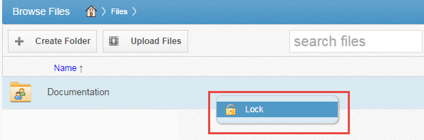
The item is now locked, and is read-only for everyone else in the share.
- Alternatively, to lock the folder or file for a specific amount of time, select Lock For. A pop-up window displays, allowing you to select a time period, including: 30 minutes, 1 hour, 3 hours, 6 hours, or 1 day.
- When you are finished editing, you must unlock the item. To unlock the item, right-click the file or folder again, and select unlock.
Viewing Lock Information
When you are working in the web portal, you can view information about who locked the file or folder.
- In the web portal, right-click the Team Share item, and select Lock Info. A dialog box displays, giving you information about who locked the item, where the item was locked, and when the lock expires.
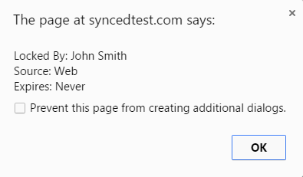

How to Lock Files and Folders in the Desktop Client
In the desktop client, you can place locks on a whole Team Share, a subfolder in a Team Share, or a file in a Team Share. When an item is locked, it will become read-only for others subscribed to the Team Share.
Manually Locking a File or Folder
To manually place a lock on a file or folder on a Windows or Mac machine:
- In the desktop client, right-click on the Team Share item, point to the sync menu, and select Lock. The Team Share item will remain locked until you unlock the item.
- Alternatively, to lock the folder or file for a specific amount of time, point to Lock for, and select a time period, including: 30 minutes, 1 hour, 3 hours, 6 hours, or 1 day.
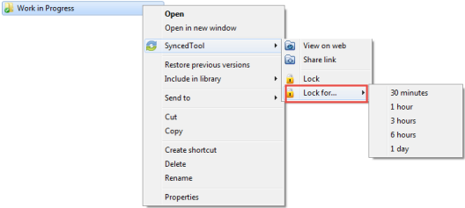
Auto-Locking Word and Excel Files
If your administrator has turned on Auto-Locking, please note expected Auto-Locking behavior:
- This feature applies to .doc, .docx, and .xlsx files. This feature also applies to .xls, .odt and .ods documents if the documents are opened with LibreOffice or OpenOffice.
- This feature is not supported for Word for Mac and .xls files opened with Excel.
- This feature is only accessible from the desktop client installed on local machines.
To open a Word or Excel file using this feature:
- Click to open a file in the Team Share. You will be presented with a dialog box that will prompt you to lock the file.
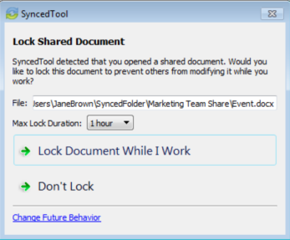
- Click Lock Document While I Work to confirm the lock. You can also select a maximum lock time period in the Max Lock Duration drop-down menu to determine how long the auto-lock will be in effect. You can select from 1 hour (default), 2 hours, 4 hours, or 8 hours. After the time period has expired, the auto-lock will expire. Or, the file will automatically unlock when you close the file.
- Depending on the administrator's configuration settings, if another user opens a file that you have locked, he or she will be presented with a read-only notification. If this notification is ignored, the user will be prompted to save the file with a different name.

Note: When attempting to edit a Microsoft Word 2013 or Microsoft Excel 2013 locked file, offending users will need to actively clear the read-only notification before they can edit a file. Older revisions of Microsoft Word, however, will only display a read-only notification in the toolbar area. It is important to be mindful when working in Team Shares, and to pay attention to display indicators and warning messages.

Viewing Lock Information
When you are working in the desktop client, you will see a lock icon displayed over a file or folder when it has been locked by you or another Team Share subscriber. Optionally, you can view information about who locked the file or folder.
- In the desktop client, right-click the Team Share item, point to the sync menu, and select Lock Info. A dialog box displays, giving you information about who locked the item, where the item was locked, and when the lock expires.
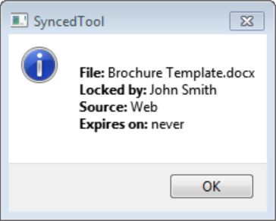

How to Resolve File Sync Conflicts
A file sync conflict occurs when a shared Team Share file that you have modified is not syncing as expected to the server. Under normal circumstances, when you modify a Team Share file on your local machine, the updated revision will synchronize to the server, and propagate across each subscribed device. When you encounter a file sync conflict, however, the modified file will not correctly sync to the server. Instead, you will see a Resolve Sync Conflicts icon, alerting you that a conflict has occurred.
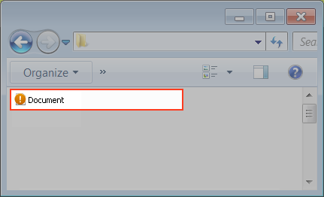

Types of File Sync Conflicts
You might encounter two different types of file sync conflicts when working in Team Shares:
- Collision—A collision occurs when one file is modified in two different places at the same time. When this happens, only one of the revisions will successfully sync to the server, and the other revision will be marked as a collision. For example, User A and User B both open the same file from two separate locations, without locking the file. User A edits and saves her file, and this new revision is synchronized to the server. User A edits and saves her file again, and this updated revision is again synchronized to the server. User B is now editing an older revision of the file. When User B saves his revision of the file, it will not synchronize to the server, and will instead be marked as a collision.
- Locked File Revision—A locked file revision occurs when a user attempts to modify a file that has been previously locked by another user, either at the file level or the folder level. For example, User A locks a file and the file is marked with a lock icon. Later, User B opens the file, ignoring the lock icon, and begins modifying the file. When User B attempts to save his revision, it does not immediately synchronize with the server, and is instead marked as a locked file revision. When User A unlocks the file, User B's revision will automatically synchronize to the server without any additional action on his part.
Your administrator can configure file locking so that locks are stronger (hard locks); in these instances, you will not encounter a locked file revision error. For more information, please contact your administrator.

Note: If Team Share subscribers forget to lock files and folders before making changes, file sync conflicts will occur more often; it is therefore considered a best practice to lock files or folders before making changes.

Resolving a Collision
To resolve a collision on a Windows or Mac machine:
- When a collision occurs, you will see a Resolve Sync Conflict icon.
- Click the icon on your computer’s system tray or menu bar, and select the Resolve Sync Conflicts link.
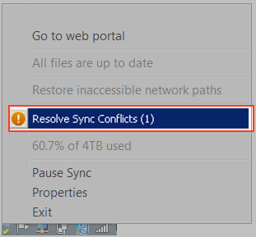

Note: On a Windows machine, the icon is located in the lower right-hand corner of the screen; on a Mac machine, the icon is located in the upper right-hand corner of the screen.

The Resolve Sync Conflicts dialog box displays.
- Use the Resolve Sync Conflicts dialog box to review information about the collision and resolve the conflict.
  - Click the Rename My revision button to rename your copy to include the term collision appended to the end. When this option is selected, you will see two files: the original_file_name file and the original_file_name (collision) file.
  - Click the Delete My revision button to discard your copy without saving changes.
  - Depending on administrative settings, you might also have the option to click the Overwrite Current button to sync your local copy as the current server revision.
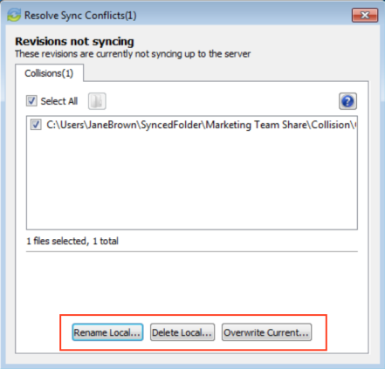
- Alternatively, you can resolve the file sync conflict directly within Windows Explorer or Mac Finder. For example, on a Windows machine, right-click the affected file, point to the sync menu, and select your preferred option.
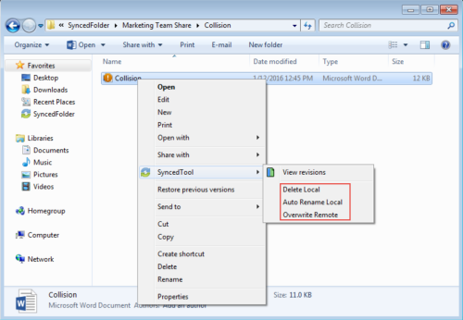

Resolving a Locked File Revision
To resolve a locked file revision on a Windows or Mac machine:
- When a locked file revision occurs, you will see a Resolve Sync Conflicts icon.
- Click the icon on your computer’s system tray or menu bar, and then click the Resolve Sync Conflicts link.

Note: On a Windows machine, the icon is located in the lower right-hand corner of the screen; on a Mac machine, the icon is located in the upper right-hand corner of the screen.

The Resolve Sync Conflicts dialog box displays.
- Use the Resolve Sync Conflicts dialog box to review details of the locked file revision conflict.
  - Click to highlight the file path that is listed in the dialog box to review who the file was locked by, when the lock expires, and so forth.
  - You can safely ignore a file sync conflict that occurs on your local machine. The system will resolve this issue for you as soon as the lock is removed.
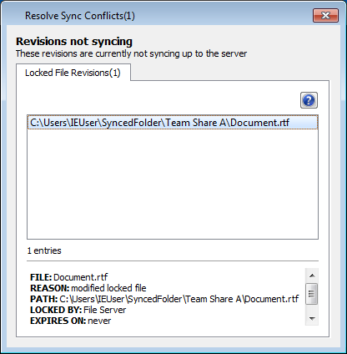

Restoring Files and Folders
The system provides many options for protecting—and optionally restoring—data. When you use the system, you can be sure that your data is safe and protected. For example, you can restore older revisions of files and folders, restore deleted files and folders, or use the Revision Rollback feature to restore all files within an entire folder to an earlier revision before a selected date.
This section will provide information on how you can protect, and optionally restore, your data.

How to View and Restore a Revision
When you edit a file, the system keeps track of each revision. Using the revisions feature in the web portal, you can view—and optionally restore—older revisions of files. This feature is useful when you make a mistake editing and saving a file, or if you want to see revisions made by other members of your Team Share.
To view and restore revisions:
- From the desktop client on your local machine, right-click a file, point to the sync menu, and select View Revisions.
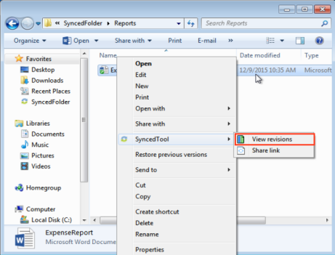
- Alternatively, if you are working in the web portal, right-click a file and select Revisions.
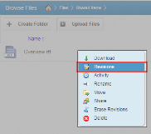
The Browse File Revisions page displays, listing all revisions of the file.
- In the Browse File Revisions page, click the title of the file to view the file in the Web Preview tool.
- Click the Download Revision link to download a previous revision. The file will download to your local machine.
- Click the Restore Revision link to overwrite the current file with the previous revision.
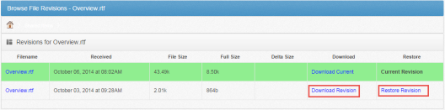

How to View and Restore Deleted Files and Folders
Depending on your administrator's settings, you can view and restore deleted files and folders from within the web portal. The ability to view and restore deleted content is one of many data protection features available to you.
To restore files and folders from the web portal:
- In the web portal, click the Files tab. The Browse Files page displays.
- In the toolbar, click the Show Deleted button.
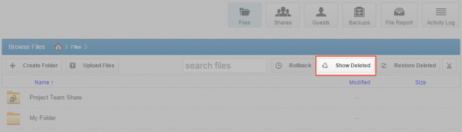
The deleted files and folders display as semi-transparent.
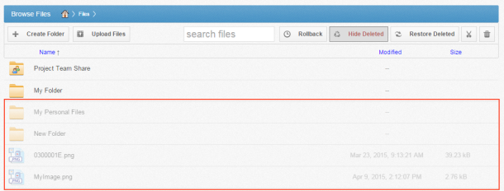
- Right-click an individual file or folder and select the Restore link.
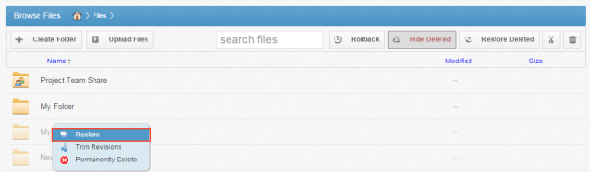
- Alternatively, to restore all deleted files in the current folder, click the Restore Deleted button in the toolbar. The Restore Files dialog box displays, allowing you to restore all deleted files, or certain files deleted between a specified time frame.
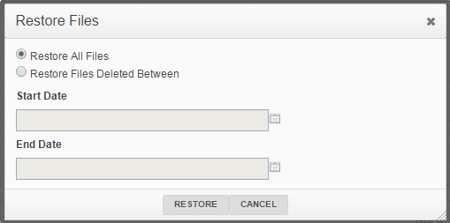
The selected files and folders will be restored.

Note: You cannot navigate away from the page until the restore process is complete.

How to Use the Rollback Feature
The Revision Rollback feature allows end users to restore all files within an entire folder (standard folder, Team Share, or Backup) to an earlier revision before a selected date. The Revision Rollback feature is particularly useful in situations where files might have been corrupted by ransomware; it utilizes a file’s revision history, and restores all currently-existing content in the root to a healthy revision at a specified point-in-time. In these cases, you can use the Activity Log to determine when the infected revisions were uploaded, and then roll back files prior to the point of infection.

Note: A file's revision can refer to the originally uploaded file (first version) or a revision of an edited file (subsequent revisions).

To access the Revision Rollback feature:
- In the web portal, click the Files tab. The Browse Files page displays.
- In the Browse Files page, navigate to the appropriate folder. While inside the folder, click the Rollback button in the toolbar.
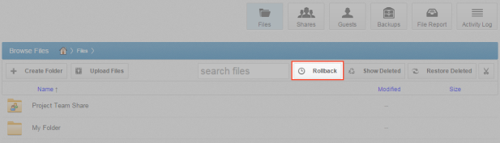
The Rollback pop-up window displays, prompting you to select a date and time.
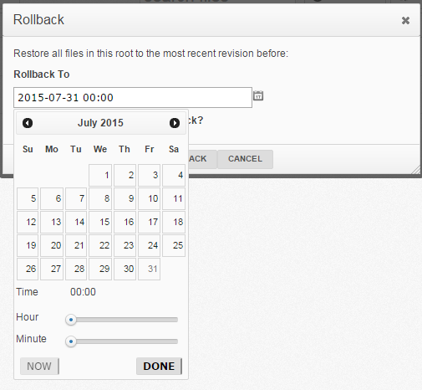
- Select a day and time before the time to which you want to restore. For example, if you select June 25th at 12:40 PM, the feature will find the first file revision before June 25th at 12:40. If a revision exists at 12:40 and another at 12:39, the file at 12:39 will be restored.
Please note that the Revision Rollback feature utilizes a 24 hour clock, and is based off of the timezone of the Anchor server. The US SaaS server is located in the Mountain timezone; the Canadian SaaS server is located in the Pacific timezone.
- Click Rollback when you are finished.

Backups
You can create backups of files and folders that exist on your local machine. You might want to create a backup of a file or folder that you want to protect, but do not want to sync. Backups do not reside in Synced Folder, and cannot be shared with another user account.
To create a backup, you can use the Backups tab in the web portal, where you can also manage and restore backups. Alternatively, you can create backups directly on your local machine.

How to Create Backups in the Web Portal
When you back up a folder, you can access your backups from the web portal and from mobile apps. All new changes are continuously backed up. Additionally, backups include revisions to files.
To back up a folder from the web portal:
- In the web portal, click the Backups tab. The Backups page displays, listing all of your existing backups.
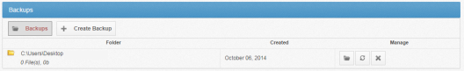
- In the Backups page, click the Create Backups button. The page refreshes to allow you to navigate your local machine and select the folder you want to back up.
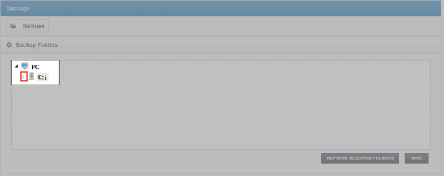
- Click the Save button when you are finished. The page refreshes to show you all backups that have been configured.
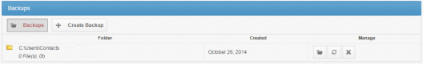

How to Create Backups on your Local Machine
In addition to backing up folders in the web portal, you can also back up your folders directly from your local machine. Like backups configured in the web portal, backups configured on your local machine continuously back up new changes, and will keep revisions.
To back up a folder from your Windows or Mac machine:
- Right-click the folder you want to back up. A menu displays.
- Point to the sync menu, and select Back up this folder.
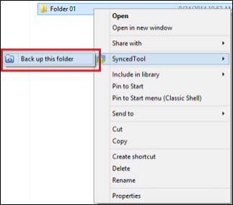
Your browser opens, displaying the newly created backup.
- To deactivate a backup from your machine, right-click the back up on your computer or laptop, point to the sync menu, and select Remove backup. The folder will no longer back up, and will be listed as deactivated in the web portal.

How to Manage Backups in the Web Portal
You can manage all backups by clicking the Backups tab in the web portal. In the Backups page, you can manage the content of backups, browse the content of backups, delete backups, or restore backups.
To manage backups:
- In the web portal, click the Backups tab. The Backups page displays, showing a list of all existing backups.
- In the Backups page, you can browse the contents of the backup.
  - Click the Browse button.
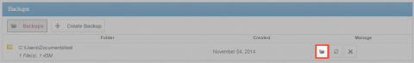
The backup opens, allowing you to browse its content.
- Inside the backup, you can also:
  - Click the Create Folder button to create a new folder inside the backup.
  - Click the Upload Files button to add files to the backup.
  - Click the Rollback button to restore all files within the entire folder to an earlier revision before a selected date. The Revision Rollback feature is particularly useful in situations where a file might have been corrupted by ransomware; it utilizes a file’s revision history, and restores all currently-existing content in the folder to a healthy revision at a specified point-in-time. In these cases, you can use the Activity Log to determine when the infected revisions were uploaded, and then roll back files prior to the point of infection.
  - Click the Show Deleted button to show files that have been deleted within the backup
  - Click the Restore Deleted button to return any deleted files to the backup.
  - Click the Erase All Revisions button to erase previous revisions to files in the backup.
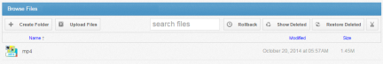
- In the Backups page, you can restore a backup to a specific location.
  - Click the Restore button.
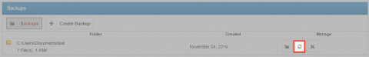
A Restore Backup page displays.
  - In the Restore Backup page, browse to select a restore point. Optionally, click the New Folder button to create a new folder as a restore point.
  - Click the Save button when you are finished.
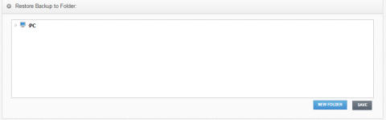
- Optionally, in the Backups page, click the Delete button to delete a backup.
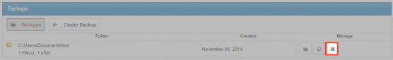
The backup will delete.

File Report and Activity Log
In addition to managing and sharing files and folders, you can also keep track of file listings and activity directly from the web portal.
With the file report, you can generate reports for all of your files, and export the report to your local machine. Use the File Report page in the web portal to generate these reports.
With the activity log, you can track all usage across the system, view audit trails, and track activity on Team Share users and guest accounts. Use the Activity Log page in the web portal to filter activity based on a set of criteria.

How to View File Reports
The File Reports page allows you to keep track of all of your content in the system from one central location. In the File Reports page, you can filter by a specific folder or Team Share. You can then view the files within the folder, the date that each file was modified, and the size of the file. You can even export the report to your local machine.
To view file reports:
- In the web portal, click the File Reports tab. The File Reports page displays.
- In the File Reports page, use the Show Reports For drop-down menu to filter files within a specific folder or Team Share. The page refreshes to show files based on your selection. The information displayed for each file includes:
  - Found In—the folder in which the file is located
  - File—the path and the file name
  - Modified—the date the file was modified
  - Size—the size of the file
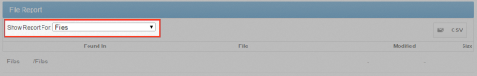
- Optionally, click the CSV button to export the report to your local machine.

How to Track Activity
The Activity Log page allows you to track activity across the system from one central location. Using the Activity Log page, you can track usage, view audit trails, and follow activity on Team Share users and guest accounts. You can even track activity performed by your guest users.
To track activity:
- In the web portal, click the Activity Log tab. The Activity Log page displays.
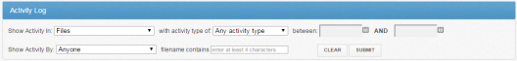
- In the Activity Log page, use the drop-down menus to filter activity based on a set of criteria.
  - Use the Show Activity In drop-down menu to select which folder or Team Share you want to track.
  - Use the with activity type of drop-down menu to select the type of activity you want to track.
  - Use the between date fields to enter the date on which the activity occurred.
  - Use the Show Activity By drop-down menu to select the user who performed the activity. This list includes guest accounts that you have created, allowing you to track activity performed by your guest users.
  - Use the filename contains textbox to enter a set of characters that should be included in the search.
- When you are finished entering criteria, click the Submit button. You will be presented with a list of activities that meet your selected criteria.

Outlook Add-In
The Outlook add-in allows you to email links to files and folders using your Microsoft Outlook application. When you use this feature, you can share links to Synced Tool items, as well as local content, directly from within your email platform. Additionally, the Outlook add-in keeps track of the items that you have shared by creating and populating a Shared Items folder in your Synced Folder.
Other benefits of the Outlook add-in include the ability to send links—rather than standard attachments—to files and folders of any size, and the ability to send items as secure shares. Additionally, when you forward an email that originally included an attachment, you have the option of converting that attachment to a share link. Because the Outlook add-in integrates with Synced Tool, you always have a backup of these shared items without needing to store attachments within your email client.

Note: Microsoft Outlook revisions 2010+ (both 32-bit and 64-bit) are supported and recommended. Microsoft Outlook for Mac does not support third-party add-ins.

Note: Disabling the Outlook setting, Use Cached Exchange Mode, will prevent the add-in from generating share links when composing emails.

Configuring the Outlook Add-In
When you configure your default settings, you can decide to
- Send notifications when a shared item is downloaded or uploaded;
- Limit the number of times a shared item is downloaded;
- Expire a shared item after a specified number of days; or
- Depending on your organization policy settings, send all items as secure shares.

Note: You can optionally configure the Outlook add-in so that all items are sent as secure shares; however, if certain policies are enabled for your organization, this feature is turned on by default, and you will not be able to configure this option.

Additionally, when configuring attachment policies, you can determine how the Outlook add-in manages your sent content. When you send items through the Outlook add-in, a new Shared Items subdirectory is created for you in your Synced Folder. By default, this folder is located at the top-level of your Synced Folder, but you can change its location when you configure your Outlook add-in preferences.
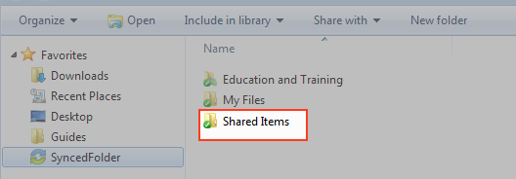
When you configure these policies, the Outlook add-in operates as a truly intelligent tool, automatically sending share links according to the way you like to work. For example, you can tell the add-in to
- Automatically use the Outlook add-in for attachments over a certain size, even when an email draft already includes a standard attachment (for example, when forwarding messages);
- Automatically use the Outlook add-in for all attachments, even when an email draft already includes a standard attachment; and
- Only use the Outlook add-in when selected.

Using the Outlook Add-In
When you compose a message in Microsoft Outlook, you use the ribbon button to attach content in a variety of ways, including
- Browse and select files and folders stored in Synced Tool,
- Browse and select a local file stored on your machine, and
- Convert an attached file to a share link, which is particularly useful when forwarding email messages that originally included a standard attachment. You can decide to manually convert these items using the Attach drop-down menu, or this will happen automatically, depending on your attachment polices.
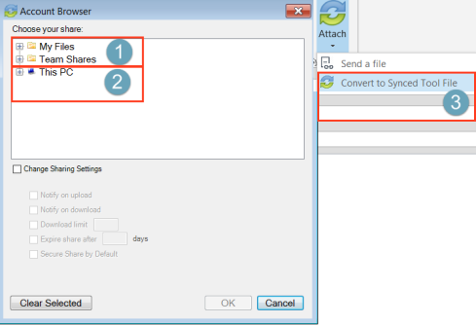

Note: When you send local files, or you convert an item to a share link, these items are stored as Synced Tool content in your Shared Items folder.

How to Install the Outlook Add-In
Before you can use the Outlook add-in, you must first download it from the web portal.
To download the Outlook add-in:
- Click the Download App button in the web portal. The Download page displays.
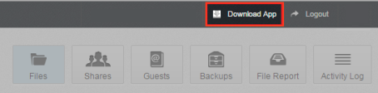
- In the Download page, click the Outlook button.
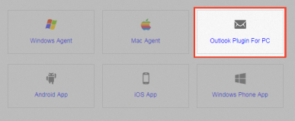
The file will start to download, or you will be prompted to save the file, depending on your browser type.
- When the file finishes downloading, make sure Microsoft Outlook is closed, and click the installation file. The Setup Wizard opens.
- Click the Next button to start the Setup Wizard.
- In the License Agreement screen, click the I accept the agreement radio button if you accept the license. Then, click the Next button to continue.
- In the Installation Directory screen, select the location where you want the installation files to reside on your local machine. In most instances, you can accept the default location. Click the Next button to continue.
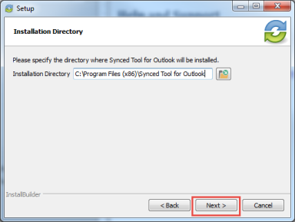
- In the Ready to Install screen, click the Next button to begin the installation process.
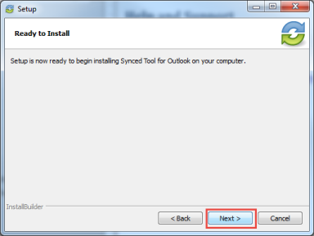
- When the Setup Wizard completes, click the Finish button.
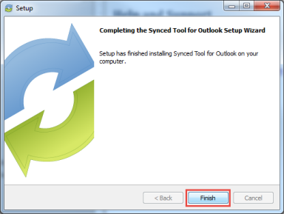

How to Configure the Outlook Add-In
After you install the Outlook add-in, you can configure default share settings and attachment policies. When you configure these settings, the Outlook add-in operates as a truly intelligent tool, automatically sending share links according to your preferences.
- When you launch Microsoft Outlook for the first time after installing the Outlook add-in, the Wizard displays, prompting you for login credentials.
  - If prompted, enter the host name of your organization in the Host field (for example, syncedtool.com).
  - In the Username field, enter the same username that you use to access the web portal.
  - In the Password field, enter the same password that you use to access the web portal.
  - Click the Next button when you are finished.
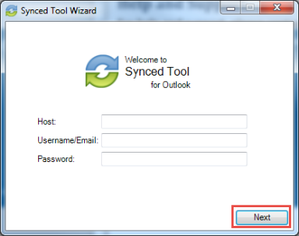
- In the Choose your Default Share Settings screen, set default settings for how you share links.
  - Click the Notify on upload checkbox to receive notifications when an item is uploaded to a shared folder.
  - Click the Notify on download checkbox to receive notifications when the share is downloaded.
  - Click the Download limit checkbox, and enter a download limit number, to limit the number of times the share is downloaded by each recipient.
  - Click the Expire share after checkbox, and enter a number of days, to set a share to expire after the specified number of days.
  - Depending on your administrator's configurations, you may also have access to the Secure Share by Default checkbox. Click this checkbox to send all content as secure shares. If this option is selected, all recipients will be required to log in to access the shared content. Recipients who are not members of your organization will be added as guest users; a guest account will be created for the recipient, and login credentials will be provided.
  - Click the Next button to continue.
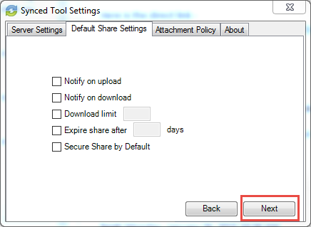
- In the next screen, set default attachment policies.
  - Click the Automatic radio button to automatically use the Outlook add-in for attachments over a certain size.
  - Click the Always use the desktop client for attachments radio button to automatically use the Outlook add-in for all attachments.
  - Click the Advanced radio button to only use the Outlook add-in when selected.
  - Click the Use default folder checkbox to use the default location for storing shares configured from Outlook. If you uncheck this checkbox, you will be prompted to select another location on your local machine.
  - Click the Next button to continue.
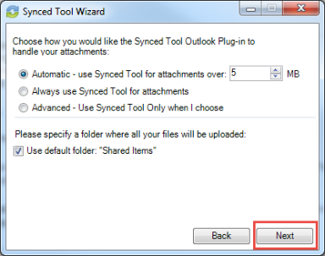
- When the Wizard completes, click the Finish button.
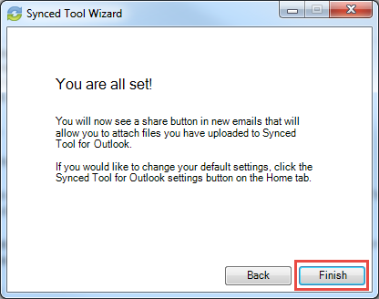

How to Use the Outlook Add-In
When you compose a message in Microsoft Outlook, you can use the Attach drop-down button to attach specific share content according to your defined preferences.
To use the Outlook add-in:
- In Microsoft Outlook, create a new email message. The ribbon will display an Attach drop-down button.
- Click the Attach drop-down button and select Send a File.
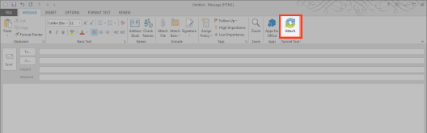
The Account Browse dialog box displays.
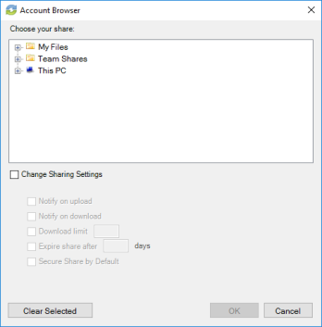
- In the Account Browser dialog box, select the content you want to share.
  - To attach a file or folder stored in Synced Tool, click to expand the My Files folder, or the Team Shares folder, and select the appropriate content.
  - To send a file from your local machine, click to expand This PC. You can then browse and select a file on your machine.
  - Optionally, you can change your default share settings by clicking the Change Share Settings checkbox.
- Alternatively, to convert an attached item to a share link, click the Attach drop-down arrow and select Convert to Synced Tool File.
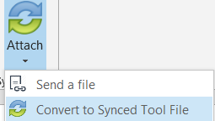
Any attached item will automatically convert to a share link, and will be stored in your Shared Items folder.
- Click Outlook's standard Send button to send your email.
- If you have selected to send a secure share link to an entire folder (rather than a single file), a Secure Share Settings dialog box will display, prompting you to configure permission for each recipient. You can set upload permissions, which allows recipients to upload content into the shared folder, or delete permissions, which allows recipients to delete content in the shared folder.
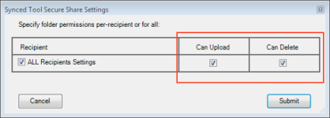
Optionally, uncheck the ALL Recipients Settings checkbox if you would like to configure separate permissions for each recipient.
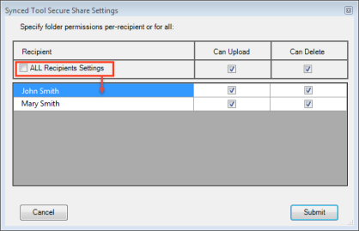

WebDAV
WebDAV allows you to map a network drive to your files in the cloud. With WebDAV, you will not have to download files or install the desktop client. Before configuring WebDAV, you should check with your administrator to ensure that this option is enabled in your system.

How to Map a Network Drive on a Windows Machine
To map a drive on a Windows machine:
- In your start menu, click Computer. The Computer dialog box displays.
- In the Computer dialog box, click the Map Network Drive button.
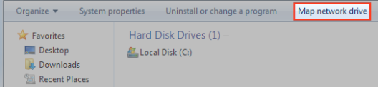
The Map Network Drive dialog box displays.
- In the Map Network Drive dialog box, configure the appropriate drive and folder.
  - In the Drive drop-down menu, select a drive letter.
  - In the Folder field, enter the location of the folder (for example, https://dav.syncedtool.com).
  - When you are finished, click the Finish button.
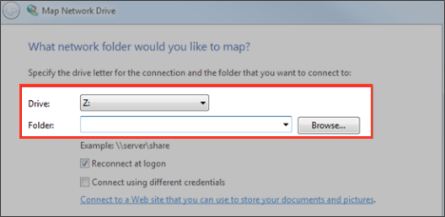
- Enter your username and password when prompted and click the OK button. Your personal folders and Team Shares will now display. You will be able to access the WebDAV folder in My Network Places.
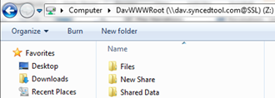

How to Map a Network Drive on a Mac OS X Machine
To map a drive on a Mac Machine:
- In Finder, click the Go menu and select Connect to Server. The Connect to Server window displays.
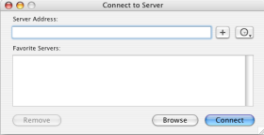
- In the Connect to Server window, enter your server address (for example, https://dav.syncedtool.com), and click the Connect button.
- When prompted, enter your username and password. Active Directory users must enter credentials as domain\username.
- When you are finished, click the Connect button.

