How to Backup / Restore the System State
Last Updated May 2011

Solution Overview
When backing up Windows domains (including Exchange data), it is critical to get a reliable backup of Active Directory (on your domain server(s)) and other critical operating system components of your servers. This set of data is called the system state. To backup the system state with eFolder, you use a feature of the Folders page that lets you add a special system state folder to the backup set. eFolder then coordinates with the operating system to take a snapshot of the system state and back it up to eFolder’s data center.
Windows 2000, XP, Server 2003 or SBS 2003 Prerequisites
eFolder requires the ntbackup utility to be installed in order to be able to take system state backups. Use Windows’ Add/Remove Components process to install ntbackup.
Next, follow the instructions in the System State Configuration section below.
Windows Server 2008 or Server 2008 R2 Prerequisites
The ntbackup utility has been replaced with a new tool, Windows Backup. The resulting system state is much larger than with ntbackup (8 GB to 12 GB). eFolder relies on the Windows Backup component to be fully installed, including the Command-line tools. Use the Server Manager tool to fully install the Windows Backup components.
Next, follow the instructions in the System State Configuration section below.
System State Configuration inside of eFolder
eFolder natively integrates with either ntbackup or Windows Backup in order to backup the system state on the desired schedule. To configure, go to the Folders page in the backup manager and click the Add button, and choose Add System State from the popup menu:
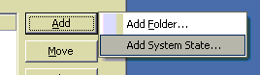
A dialog will appear that allows configuration of the system state backups:
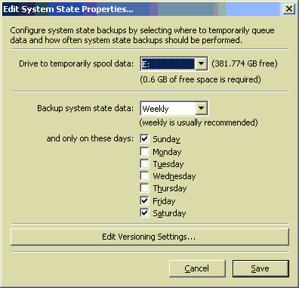
Choose the drive that the system state will temporarily be spooled on. We highly recommend choosing a drive that is not the drive that contains the operating system. For versions of Windows prior to Server 2008 only 1 GB of free space is required. On Server 2008 and later, up to 20 GB of free space is required.
Next, set a system state backup schedule. We highly recommend only taking the system state backup on a weekly basis if you are running Server 2008 or better because of the size of the system state backups. Note that you do not set a time for the system state backup to run. eFolder will perform the system state backup at the start of a normal backup as appropriate.
If desired, click Edit Versioning Settings and change the Number of Days to Keep Deleted Files to be less than 7 (especially helpful to minimize disk usage for Server 2008 system state backups). If you do not want to retain more than one version of the system state backup, set this to 0.
Finally, click the Save button and save all changes.
Restoring the System State on Windows 2000, XP, Server 2003 or SBS 2003
To restore the system state, use the file manager application to download the .bkf file from the @SysState folder in your account. Then use the ntbackup application to connect to the .bkf file and restore the system state. If the server is a domain controller, you will need to reboot the server into ‘Directory Services Recovery Mode’ before you can restore the system state.
Restoring the System State on Server 2008 or Server 2008 R2
Follow these steps:
- Use eFolder to restore the System State backup files to a local drive:
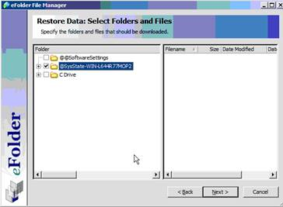
- Once the restore is complete, locate the recovered @SysState folder on your drive:
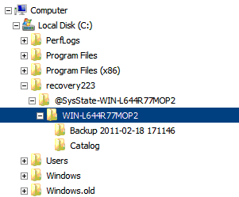
- Rename the @SysState-computername folder named after your computer (for example @SysState-WIN-L644R77MOP2) to "WindowsImageBackup"
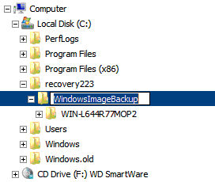
- If necessary, move the WindowsImageBackup folder to the root of the drive:
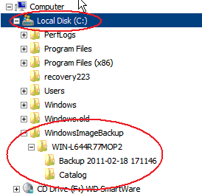
- If this is a domain controller, reboot into Directory Services Recovery Mode.
- The key is to rename the restored @SysState folder “WindowsImageBackup” and place it in the root of the local or external drive. Then, when you run Windows Server Backup recovery, choose the option for "A backup stored on another location." Select the location to the drive where you saved the folder (whether it is on the c: drive or another), and it will detect the backup files and allow you to restore.
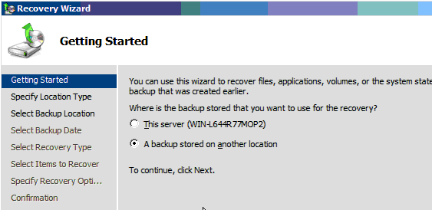
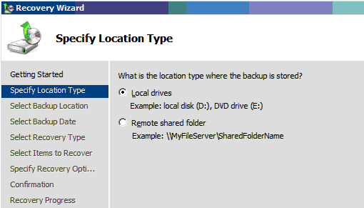
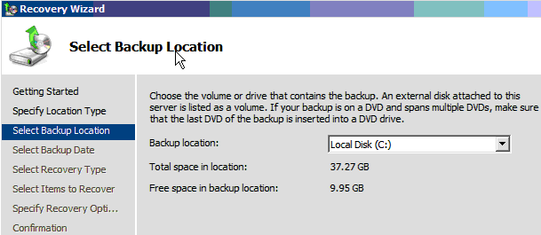
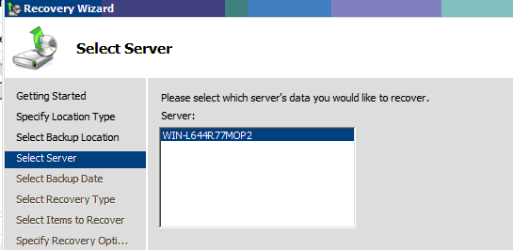
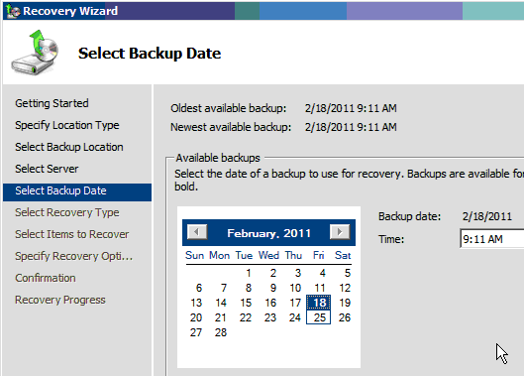
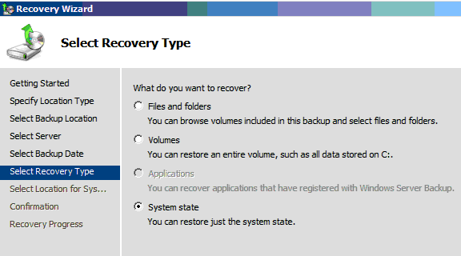
Additional Assistance
We will assist you any way that we can. Please submit questions to support@efolder.net, call us at 800-352-0248, or browse our knowledge base at https://secure.efoldering.com/support/kb/

